# Arduino UNO R3 Smart Car Kit Manual

## Description

This kit provides a comprehensive set of hardware components aimed at facilitating Arduino-based projects. It includes an Arduino UNO R3 development board as the central control unit, along with peripherals such as an ultrasonic sensor for distance measurement, an infrared line tracking module for path following, a DRV8833 driver board for motor control, and a HAT board with LED indicators, power management switches, and motor interfaces. Additionally, it features N20 reduction motors, a JYD-31 Bluetooth module for wireless communication, and an Android smartphone app for remote control and monitoring. This kit enables users to easily develop projects ranging from obstacle-avoiding robots to smart vehicles, providing a versatile platform for innovation and experimentation.

## Features

* Arduino UNO R3 Development Board: Serving as the core control unit, it boasts powerful processing capabilities and abundant expansion interfaces, enabling the development and realization of various projects.
* Ultrasonic Sensor: Used for distance measurement, it enables intelligent obstacle avoidance, enhancing the stability and reliability of projects in complex environments.
* Infrared Line Tracking Module: Capable of intelligent path following, it equips projects with automatic navigation and positioning capabilities.
* DRV8833 Driver Board: Providing robust motor driving capabilities, it supports the control of DC motors, enabling projects to perform motion and action execution.
* HAT Board: Specifically designed for the Arduino UNO R3, it offers rich interfaces and functions, including LED indicators, power management switches, and fail-safe motor interfaces, making hardware connections more convenient and reliable.
* N20 Reduction Motors: Utilizing N20 reduction motors, they offer stability and efficiency, suitable for various mechanical motion control scenarios.
* JYD-31 Bluetooth Module: Through Bluetooth connection, it achieves wireless communication and control with Android smartphones, granting projects remote control and monitoring capabilities.
* Android Smartphone App: Providing a user-friendly mobile application, it allows users to easily control and monitor various functions of the kit, enhancing user experience and interactivity.

## Package Includes

## Getting Start

### Understanding components

#### 1. IR Line Tracking Module

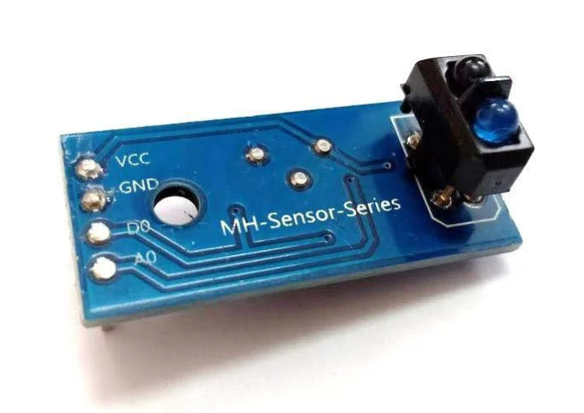

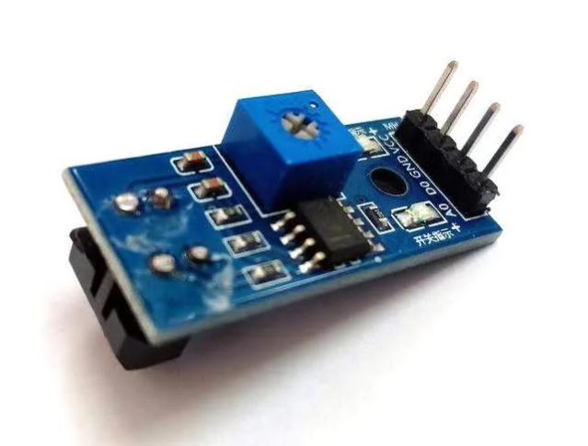

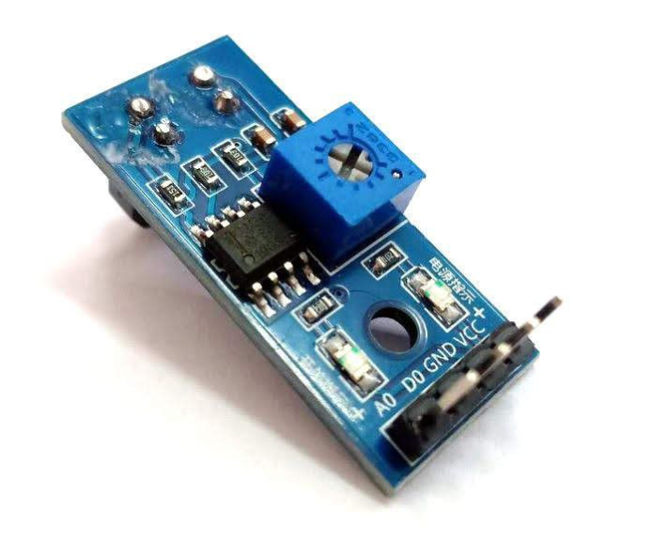

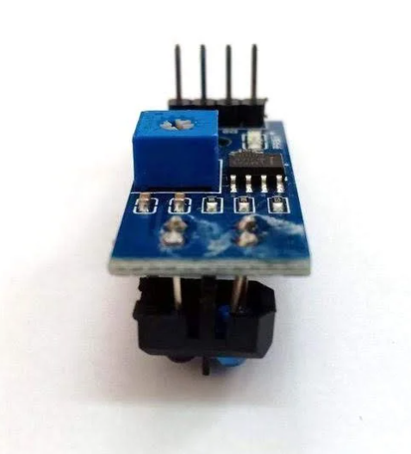

The Line Tracking module is an infrared sensor that detects whether the surface in front of it is reflective or opaque. Sensitivity to ambient light can be adjusted using the knob to achieve a fairly accurate reading.

This sensor is typically used on wheeled robots and can operate at 3.3V to 5V which makes it compatible with a variety of microcontrollers like Arduino, ESP32, Raspberry Pi, ESP8266, Teensy, and others.

It’s Operating voltage is 3.3V or 5VDC, 4-pin interface which are: **AO, DO, GND and VCC**:

* **AO** is an analog output pin; the analog voltage will be high when there is no obstacle or infrared reflection. The voltage will gradually decrease when the infrared receives it high.
* **DO** is a digital output pin from the sensor module, please connect to any digital input on your microcontroller. Output logic will be LOW when object is detection.
* **GND** is where you connect to your controller ground or 0V
* **VCC** is the + Power supply, connect to either +3.3V or +5V
* **Two LED indicators**: Power indicator LED and Object detection indicator LED
* **Obstacle detection range**: 5mm to 10mm from the sensor
* Adjustable sensitivity with an onboard potentiometer, this translates to an adjustable detection range.

#### 2. Ultrasonic Sensor

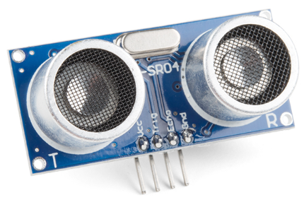

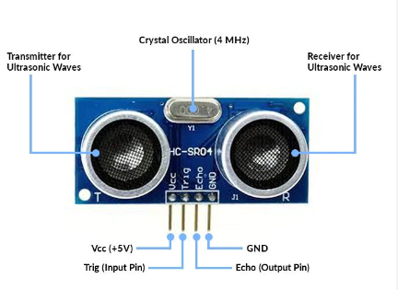

An ultrasonic sensor is an instrument that measures the distance to an object using ultrasonic sound waves.

An ultrasonic sensor uses a transducer to send and receive ultrasonic pulses that relay back information about an object’s proximity.

High-frequency sound waves reflect across boundaries to produce distinct echo patterns.

The HC-SR04 is an affordable and easy to use distance measuring sensor which has a range from 2cm to 400cm (about an inch to 13 feet).

The sensor is composed of two ultrasonic transducers. One is transmitter which outputs ultrasonic sound pulses and the other is receiver which listens for reflected waves. It’s basically a SONAR which is used in submarines for detecting underwater objects.

|  |  |
| --- | --- |
| Operating Voltage | 5V DC |
| Operating Current | 15mA |
| Operating Frequency | 40KHz |
| Min Range | 2cm / 1 inch |
| Max Range | 400cm / 13 feet |
| Accuracy | 3mm |
| Measuring Angle | <15° |

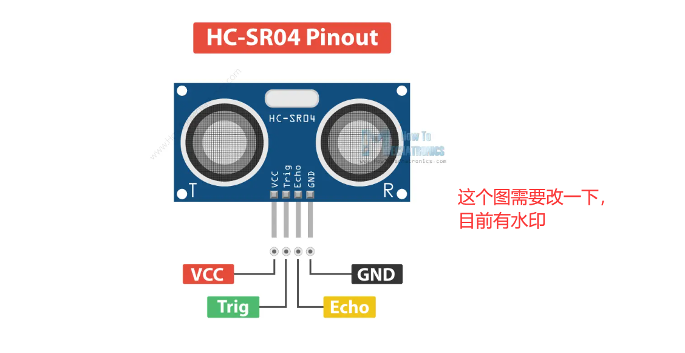

The sensor has 4 pins. VCC and GND go to 5V and GND pins on the Arduino, and the Trig and Echo go to any digital Arduino pin. Using the Trig pin we send the ultrasound wave from the transmitter, and with the Echo pin we listen for the reflected signal.

##### How the HC-SR04 Ultrasonic Distance Sensor Works?

It emits an ultrasound at 40 000 Hz which travels through the air and if there is an object or obstacle on its path It will bounce back to the module. Considering the travel time and the speed of the sound you can calculate the distance.

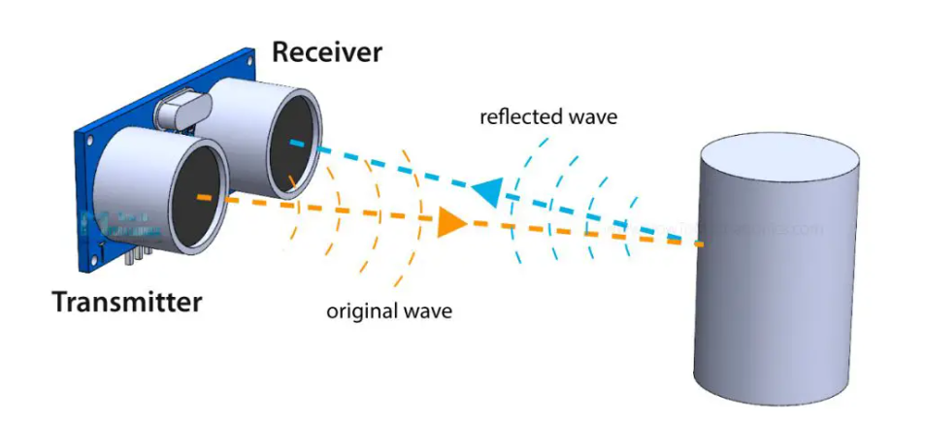

##### How Ultrasonic Sensor Working Principle - Explained

In order to generate the ultrasound, we need to set the Trig pin on a High State for 10 µs. That will send out an 8 cycle ultrasonic burst which will travel at the speed of sound. The Echo pins goes high right away after that 8 cycle ultrasonic burst is sent, and it starts listening or waiting for that wave to be reflected from an object.

If there is no object or reflected pulse, the Echo pin will time-out after 38ms and get back to low state.

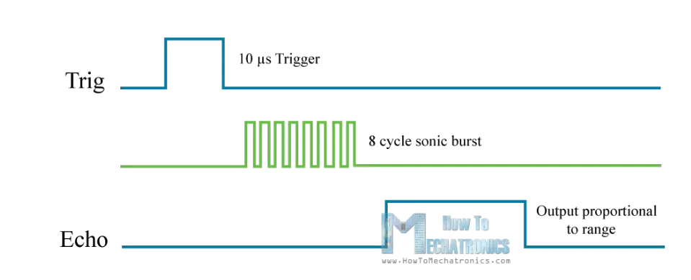

If we receive a reflected pulse, the Echo pin will go down sooner than those 38ms. According to the amount of time the Echo pin was HIGH, we can determine the distance the sound wave traveled, thus the distance from the sensor to the object.

For that purpose, we are using the following basic formula for calculating distance:

**Distance = Speed x Time**

We actually know both the speed and the time values. The time is the amount of time the Echo pin was HIGH, and the speed is the speed of sound which is 340m/s. There’s one additional step we need to do, and that’s divide the end result by 2. and that’s because we are measuring the duration the sound waves needs to travel to the object and bounce back.

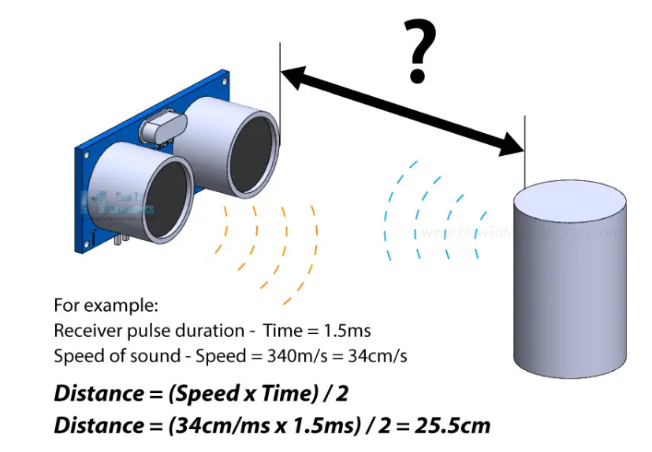

Let’s say the Echo pin was HIGH for 2ms. If we want the get the distance result in cm, we can convert the speed of sound value from 340m/s to 34cm/ms.

**Distance = (Speed x Time) / 2 = (34cm/ms x 1.5ms) / 2 = 25.5cm.**

So, if the Echo pin was HIGH for 2ms (which we measure using the **pulseIn()** function), the distance from the sensor to the object is 34cm.

#### 3. DRV8833 Motor Driver

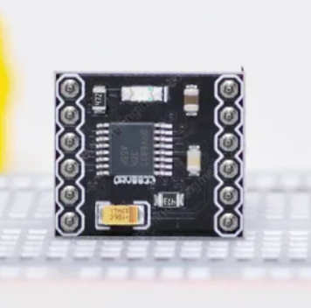

At the heart of the module is an integrated H-Bridge driver IC from Texas Instruments that is optimized for motor driving applications – The DRV8833.

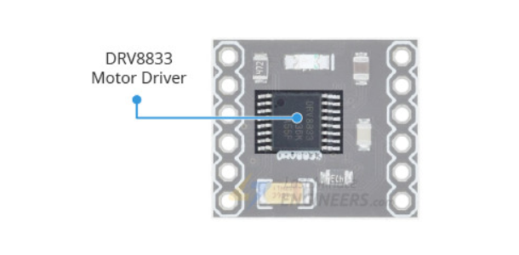这个图有水印，需要去掉。。

The DRV8833 features two NMOS H-bridge drivers, enabling it to control two DC brush motors, a bipolar stepper motor, solenoids, and other inductive loads.

It operates in a voltage range from 2.7 V to 10.8 V, and can continuously supply up to 1.2 A per channel. Additionally, it can tolerate peak currents up to 2 A per channel for a few seconds.

The DRV8833 also contains a number of protection features, such as under-voltage lockout, over-current, and over-temperature protection, offering a high level of reliability. Each of these events will disable the H-Bridge MOSFETs. After a fault condition has been removed, the device will resume its operation.

It also includes a low-power sleep mode, which lets you save power, especially when the motors are not in use.

All these features make it an excellent choice for powering small, low-voltage motors.

##### Technical Specifications

Here are the specifications:

* Motor Voltage：2.7V – 10.8V
* Logic Voltage：3V- and 5V-compatible
* Continuous Output Current：1.2A (Per Channel)
* Peak Output Current：2A (Per Channel)
* Motor Channels：2
* Protection Features：under-voltage lockout, over-current, and over-temperature

##### DRV8833 Motor Driver Pinout

The DRV8833 driver has a total of 12 pins that connect it to the outside world. The pinout is as follows:

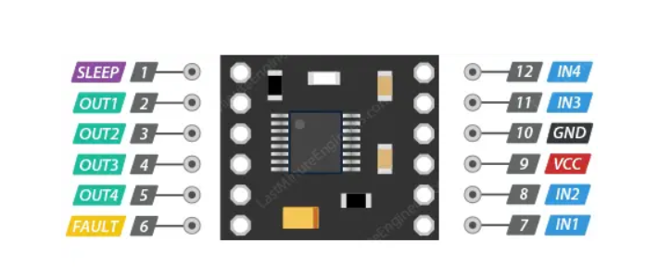

###### Power Pins

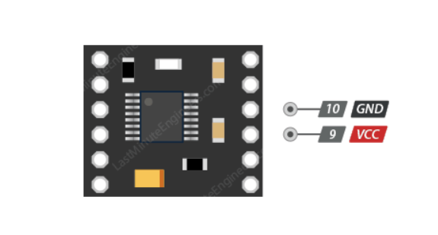

VCC and GND is where you connect the power supply that drives the motors, which can be in the range of 2.7V to 10.8V.

*Note that the DRV8833 can work with voltages as low as 2.7V. This means it’s perfect for low-voltage projects, like those running on single-cell LiPo batteries and low-voltage motors.*

###### Output Pins

The output pins of the DRV8825 motor driver, namely OUT1, OUT2, OUT3, and OUT4, are conveniently located on one side of the module for easy interfacing.

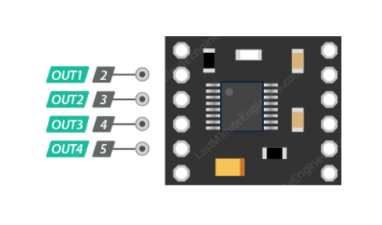

本图的水印要去掉，或者手绘一个。

Motor A should be connected to OUT1 and OUT2, while Motor B should be connected to OUT3, and OUT4. You can connect any brushed DC motor ranging from 2.7 V to 10.8 V to these pins.

Keep in mind that the DRV8833 can deliver 1.2 A per channel continuously (2 A peak) to a pair of DC motors.

###### Control Input Pins

Each motor has two control inputs; IN1 and IN2 are the control inputs for Motor A, while IN3 and IN4 are for Motor B. These control inputs allow you to control both the speed and spinning direction of the motor.

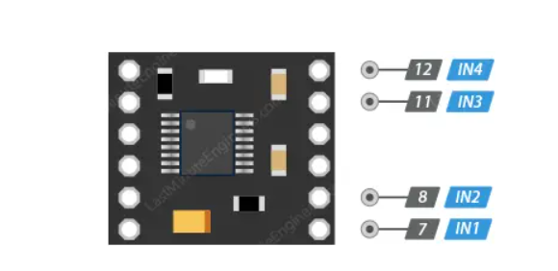

###### Direction Control:

The spinning direction of the motor can be controlled by applying logic HIGH (5V) or logic LOW (Ground) to these inputs. The truth table below shows how the inputs affect the driver outputs.

|  |  |  |
| --- | --- | --- |
| IN1/IN3 | IN2/IN4 | Spinning Direction |
| LOW(0) | LOW(0) | Motor OFF |
| HIGH(1) | LOW(0) | Forward |
| LOW(0) | HIGH(1) | Reverse |
| HIGH(1) | HIGH(1) | Motor OFF |

###### Speed Control:

If you want to control speed, you can use Pulse Width Modulation (PWM) on the pin that’s usually high. If speed control isn’t needed, just set them to either HIGH or LOW.

*Note that the control inputs are pulled low internally, effectively disabling the motor driver outputs by default.*

###### Sleep Mode Pin

The SLEEP pin (labeled EEP on the board silkscreen) controls the DRV8833’s sleep mode. Setting this pin low puts the DRV8833 into a low-power sleep mode, while setting it high makes it active again.

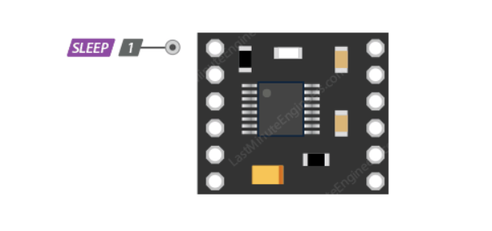

In this mode, the H-bridges are disabled, the gate drive charge pump is stopped, all internal logic is reset, all internal clocks are stopped, and all inputs are ignored. It’s important to note that when returning from sleep mode, the motor driver needs a little time, up to 1 millisecond, to become fully operational again.

By default, the SLEEP pin is pulled high on the board, so if you don’t plan to use the low-power sleep mode, you can just leave it disconnected.

On the backside of the DRV8833 module, there’s a solder jumper J1.

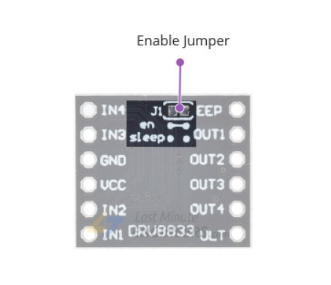

By default, J1 is closed, which connects an on-board pull-up to the SLEEP pin, thereby keeping the DRV8833 enabled. However, if you open J1, the onboard pull-up gets disconnected from the SLEEP pin. This action enables the on-chip pulldown, which means that the DRV8833 will stay disabled by default. So, if you choose to open J1, remember that you’ll need to manually turn the DRV8833 on when needed.

###### Fault Detection Pin

The FAULT pin (labeled ULT on the board silkscreen) is an open-drain output that is driven low by the chip whenever an over-current, over-temperature-or under-voltage condition occurs.

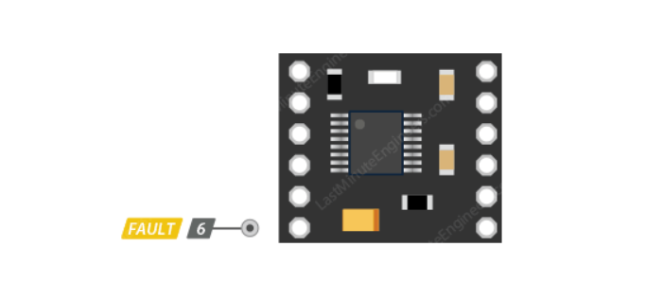

By default, this pin remains in a floating state. So, if you want to monitor fault conditions on the driver, you will need to connect an external pull-up resistor (or use a microcontroller input with its built-in pull-up enabled).

###### Current limiting

The DRV8833 can actively limit the current passing through the motors. This is generally accomplished by connecting a resistor between AISEN pin and ground to set the limit for Motor A, and another resistor between BISEN pin and ground to set the limit for Motor B.

However, this specific DRV8833 breakout board connects these current sense pins directly to ground, effectively disabling the current limiting feature.

#### 4. JYD-31 Bluetooth Module

JDY-31 Bluetooth is based on Bluetooth 3.0 SPP design, which can support Windows, Linux, android data transmission, working frequency band 2.4GHZ, modulation mode

GFSK, maximum transmission power 8db, maximum transmission distance 30 meters, support users to modify device name through AT command The baud rate and other

instructions are convenient and quick to use.

###### Applications:

JDY-31 is a classic Bluetooth protocol that can communicate with Bluetooth-enabled

computers (desktops, notebooks) and mobile phones (android). Can be applied

* Windows computer Bluetooth serial port transparent transmission
* Android Bluetooth serial port transparent transmission
* Smart home control -Automotive ODB testing equipment -Bluetooth toy
* Share mobile power, share weight -Medical equipment

###### Parameter:

* Model: JDY-31
* Working frequency band: 2.4GHZ
* Communication interface: UART
* Operating voltage: 1.8-3.6V (3.3V recommended)
* Working temperature: -40 ° C - 80 ° C
* Antenna: Built-in PCB antenna
* Transmission distance: 30 meters
* Master-slave support: slave
* Module size: 19.6 * 14.94 * 1.8 mm (length, width, height)
* Bluetooth version: Bluetooth 3.0 SPP
* STM soldering temperature: <260°C
* Unconnected operating current: 4.7mA
* Current after BLE connection: 7.3mA
* Transmitting power: 8db (maximum)
* Receive sensitivity: -97dbm
* TXD/RXD Level: TTL Level
* SPP maximum throughput: 16K bytes/s (android, windows)

###### JDY-31 support patch and solder pin header

* Needle pin application: The pin header specification is standard 2.54 pitch pin header, just need to weld 5 pin holes on the module
* patch application: general application only need to connect **VCC, GND, RXD, TXD** 4 pins, if you need to actively disconnect in the connection state, send **AT+DISC** in the connection state.

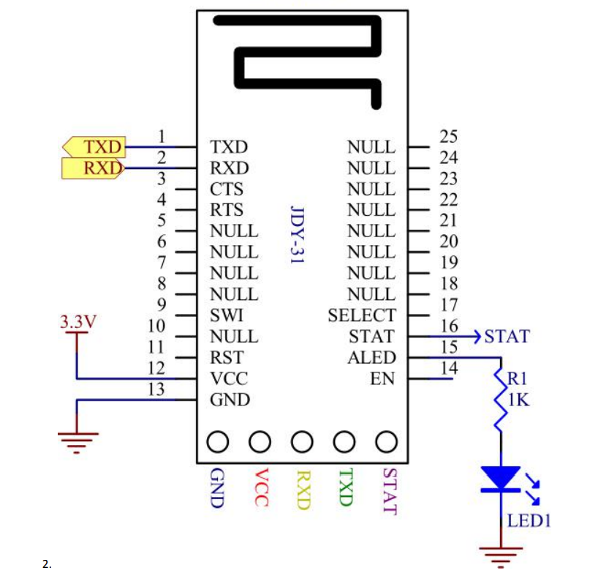

###### Serial AT instruction set

JDY-31 module serial port sending AT command must be added\r\n

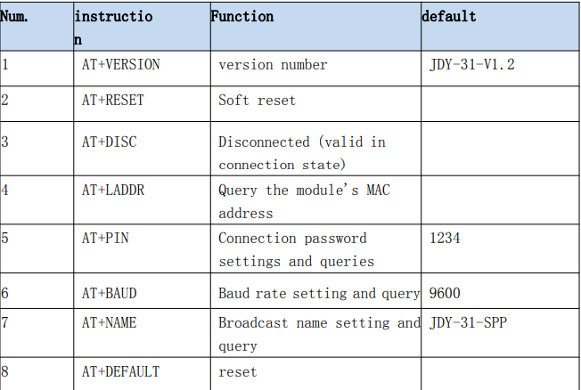

1. Question Version Number

|  |  |  |
| --- | --- | --- |
| Instruction | Response | Parameter |
| AT+VERSION | +VERSION=JDY-31-V1.2,Bluetooth V3.0 | NO |

2. Reset

|  |  |  |
| --- | --- | --- |
| Instruction | Response | Parameter |
| AT+RESET | +OK | NO |

3. Disconnect

|  |  |  |
| --- | --- | --- |
| Instruction | Response | Parameter |
| AT+DISC | +OK | NO |

Valid after connection

4. BLE Bluetooth MAC Address

|  |  |  |
| --- | --- | --- |
| Instruction | Response | Parameter |
| AT+LADDR | +LADDR=<Param> | NO |

5. Baud Rate Setting / Query

|  |  |  |
| --- | --- | --- |
| Instruction | Response | Parameter |
| AT+BAUD<Param> | +BAUD=<Param> | Param:<4-9> |
| 4: 9600 |
| 5: 19200 |
| 6: 38400 |
| 7: 57600 |
| 8: 115200 |
| 9: 128000 |

JDY-31 supports 128000 baud rate continuous data transmission and transmission, and does not lose packets, the transmission speed can reach 16Kbytes per second.

6. SPP Bluetooth pairing password

|  |  |  |
| --- | --- | --- |
| Instruction | Response | Parameter |
| AT+PIN<Param> | +OK | Param:4-digit password  Default PIN：1234 |
| AT+PIN | +PIN=<Param> |

7. Broadcast name settings / query

|  |  |  |
| --- | --- | --- |
| Instruction | Response | Parameter |
| AT+NAME<Param> | +OK | Param:BLE broadcast |
| AT+NAME | +NAME=<Param> | Name is the longest: 18 bytes  Default broadcast name:  JDY-31-SPP |

8. Restore factory configuration

|  |  |  |
| --- | --- | --- |
| Instruction | Response | Parameter |
| AT+DEFAUTLT | +OK | NO |

#### 5. HAT board

This Hat board will provide you with a convenient access interface, allowing you to complete the hardware construction of the car faster.

The onboard LED light can be used as a vehicle status light display and can be operated through pin programming. You can use the method you like to make it flash or stay on.

It can be perfectly snapped into the Arduino UNO series motherboard, and is equipped with a power switch that can be turned off when debugging the code to avoid disoperation causing the vehicle to fall.

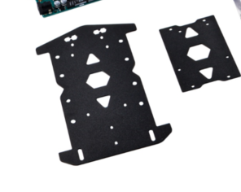

### How to Assemble it?

Please assemble the smart car kit according to following steps in the figure.

#### Product Outlook:

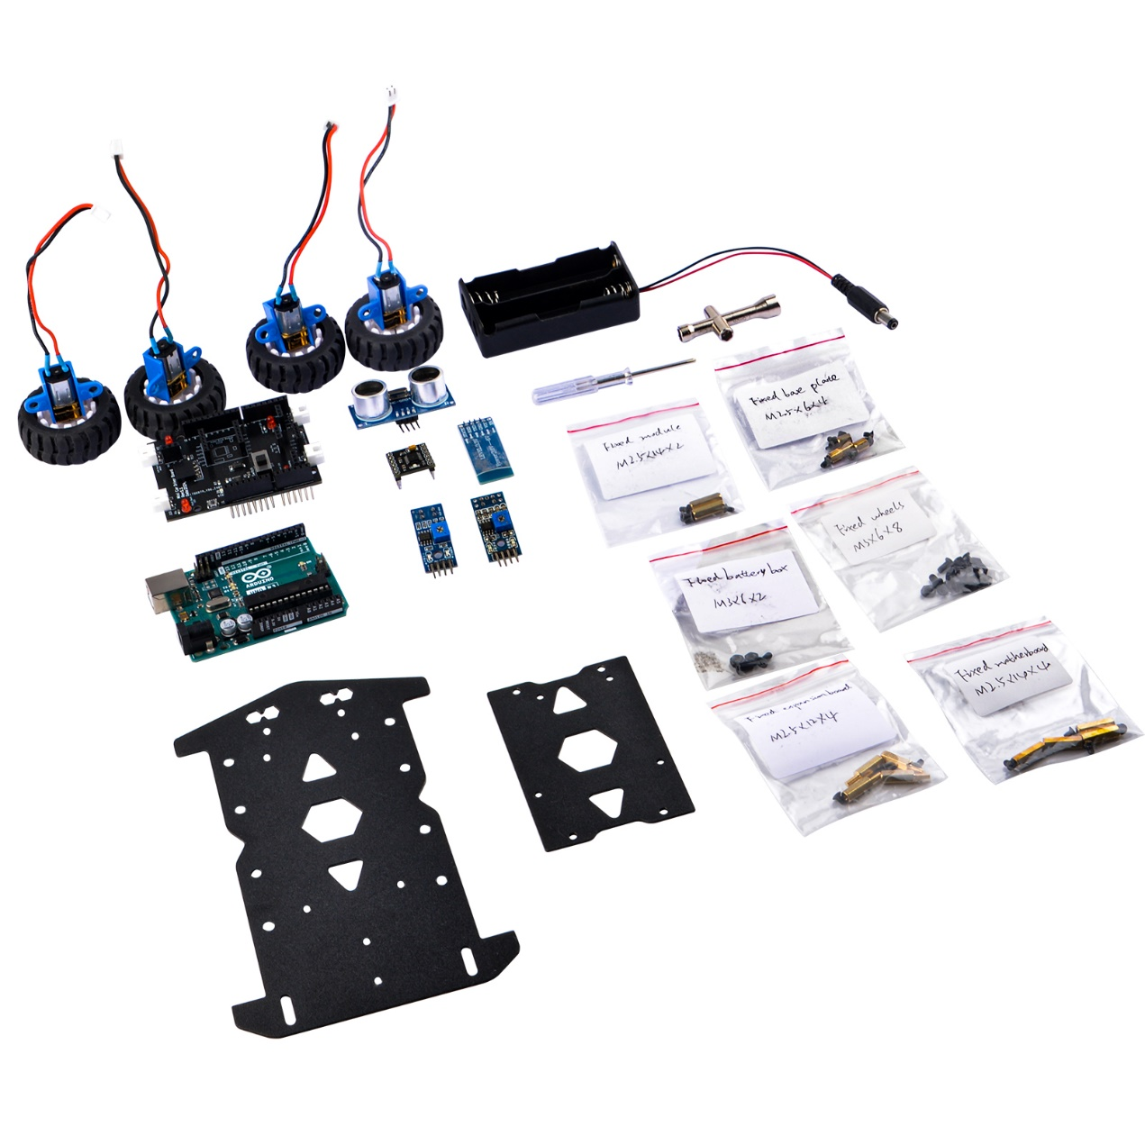

#### Step 1: Install the trolley chassis

To install the N20 motors, begin by attaching each motor to its respective motor holder using M3 screws and nuts, ensuring they are securely fastened. Then, solder the cables onto each motor, ensuring proper polarity alignment. Next, affix the rubber wheels onto the motor shafts, ensuring they are snugly fitted. Once all components are assembled, place the motors in the desired configuration, ensuring proper alignment and spacing between wheels. Finally, connect the motors to the appropriate power source and test the functionality to ensure smooth operation.

The reason for installing the front wheels with an outer eight and the rear wheels with an inner eight configurations may be to enhance maneuverability and stability. Placing the front wheels on outer brackets allows for increased agility and responsiveness during steering, making it easier to turn. On the other hand, positioning the rear wheels on inner brackets contributes to improved stability and traction, particularly during high-speed driving or cornering, reducing the risk of slipping or skidding and providing better control over the vehicle's movement.

Camber angle is the angle of the wheel relative to the vertical axis when viewed from the front or rear of the vehicle. It is the tilt of the wheel either towards the vehicle (negative camber) or away from it (positive camber).

Negative camber occurs when the top of the wheel leans inward towards the vehicle. This setup is often used in performance vehicles or racing cars as it can improve cornering grip and stability by keeping more of the tire's contact patch on the road during hard cornering. However, excessive negative camber can lead to uneven tire wear, particularly on the inside edge of the tires.

Positive camber occurs when the top of the wheel leans outward away from the vehicle. It is less common in modern vehicles and is usually associated with older vehicles or certain specialized applications. Positive camber can provide better stability in certain situations, such as when carrying heavy loads, but excessive positive camber can lead to reduced grip and uneven tire wear on the outer edges of the tires.

The appropriate camber angle for a vehicle depends on factors such as the vehicle's suspension geometry, intended use, and driver preferences. It is often adjusted during wheel alignment to optimize tire wear, handling, and stability.

Fix the motor holder with M3 screws and nuts, and put the cable through the holes on the metal plate.

NOTE:

Here you need to make sure the

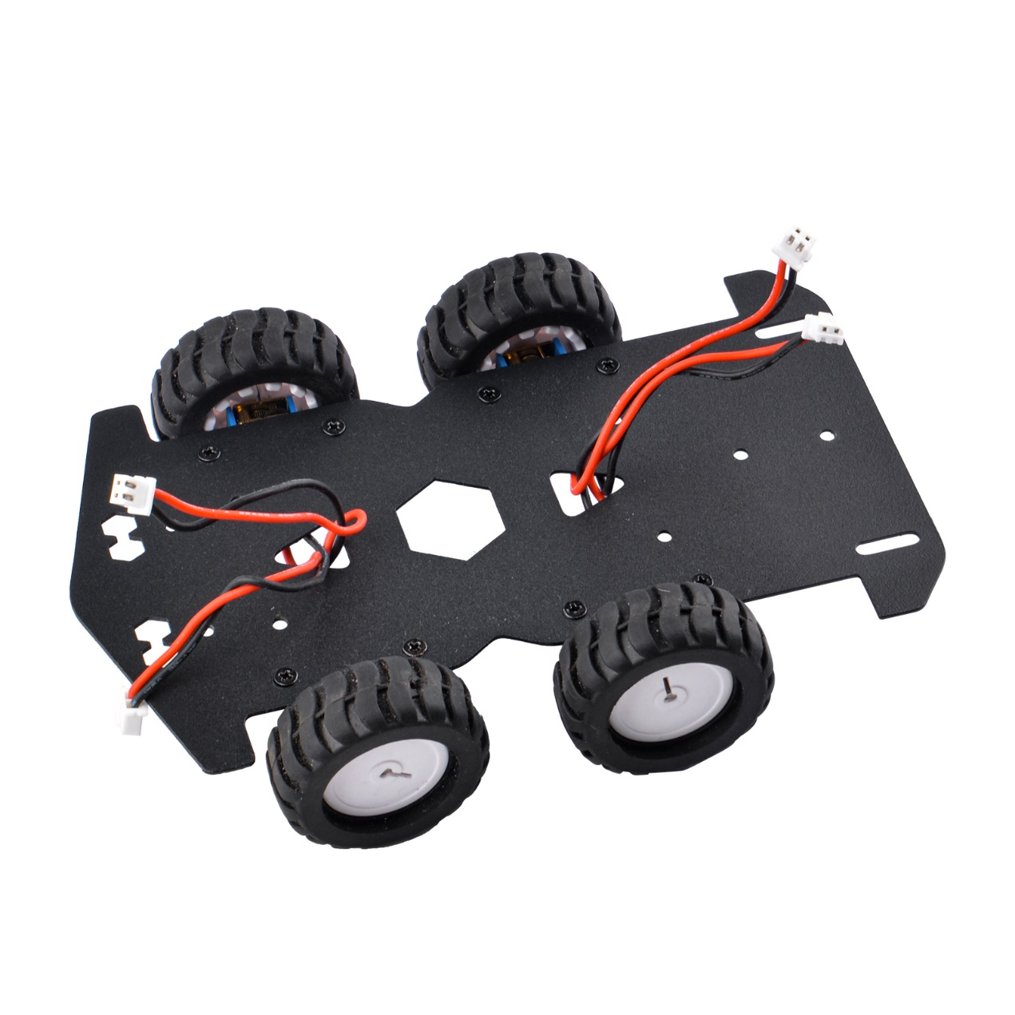

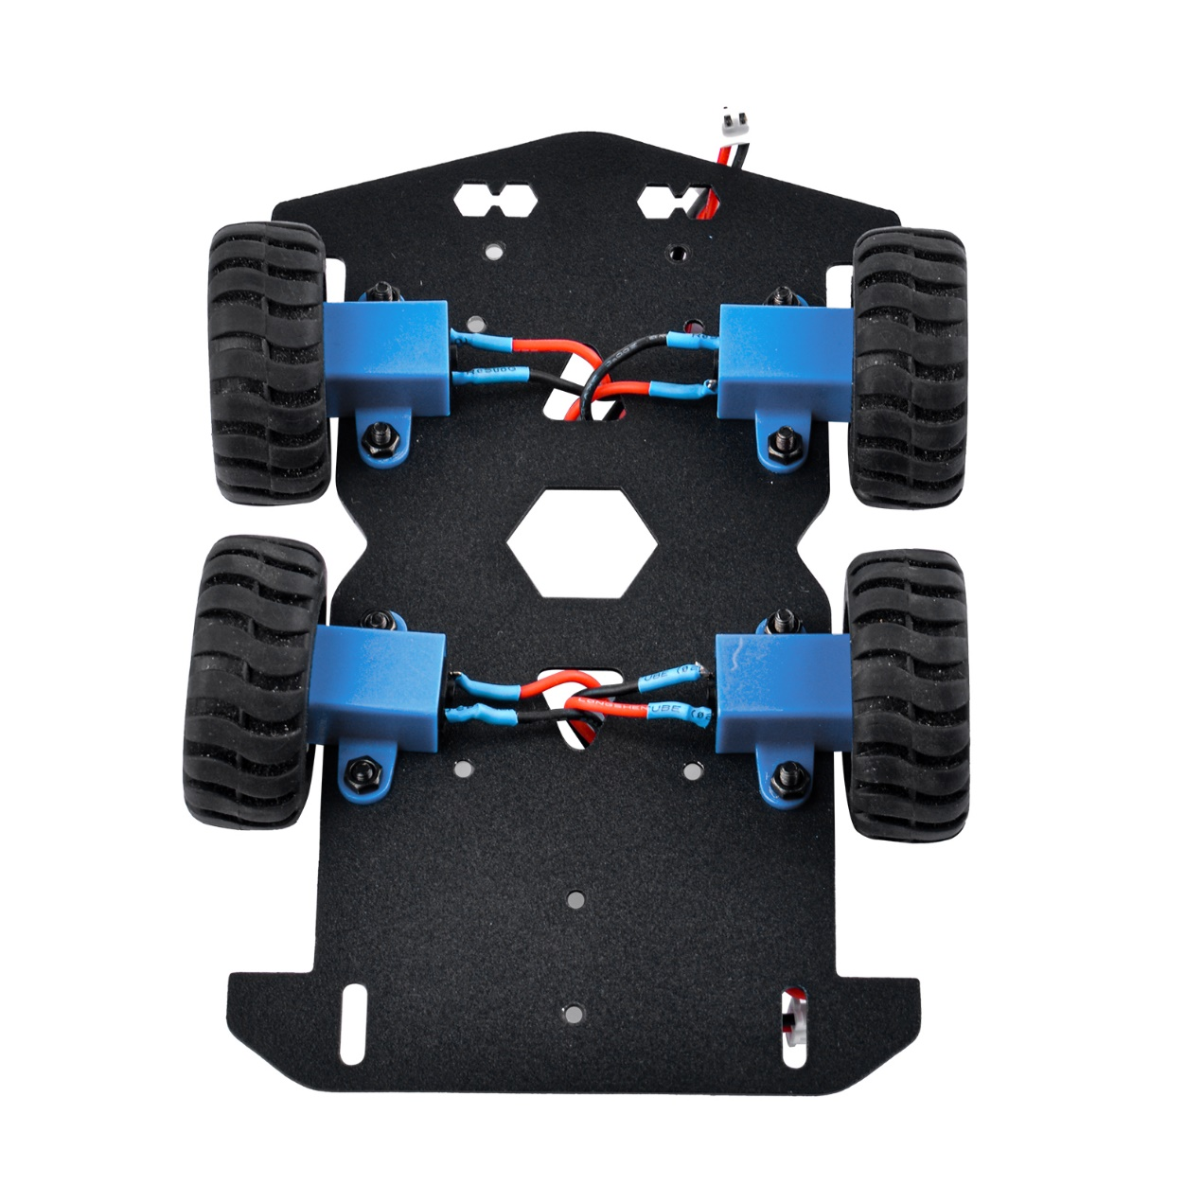

#### Step 2: Install the host computer part

NOTE:

Insert the Arduino UNO R3 and the car's expansion board according to the pin alignment. Before inserting, please carefully observe the installation method of the copper pillars.

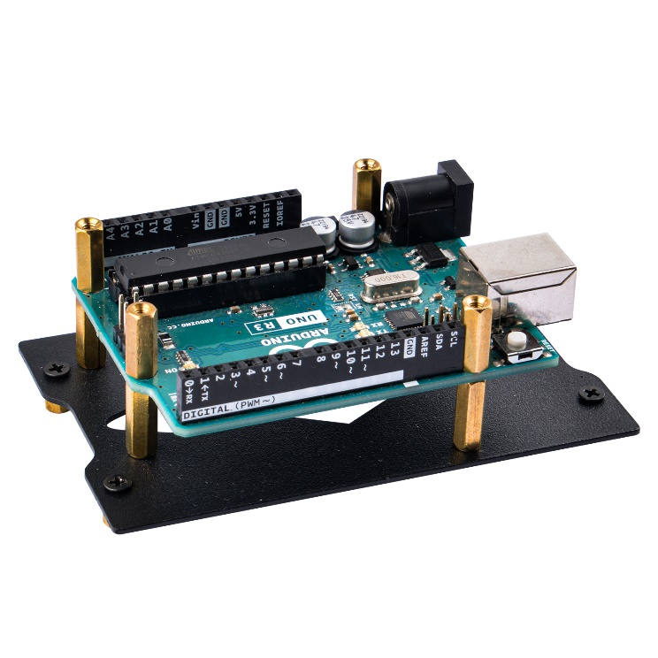

Fix the small copper pillar to the metal panel with M2.5 flat head screws.

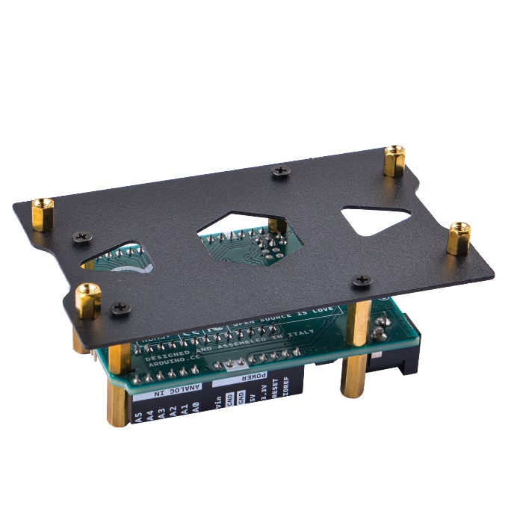

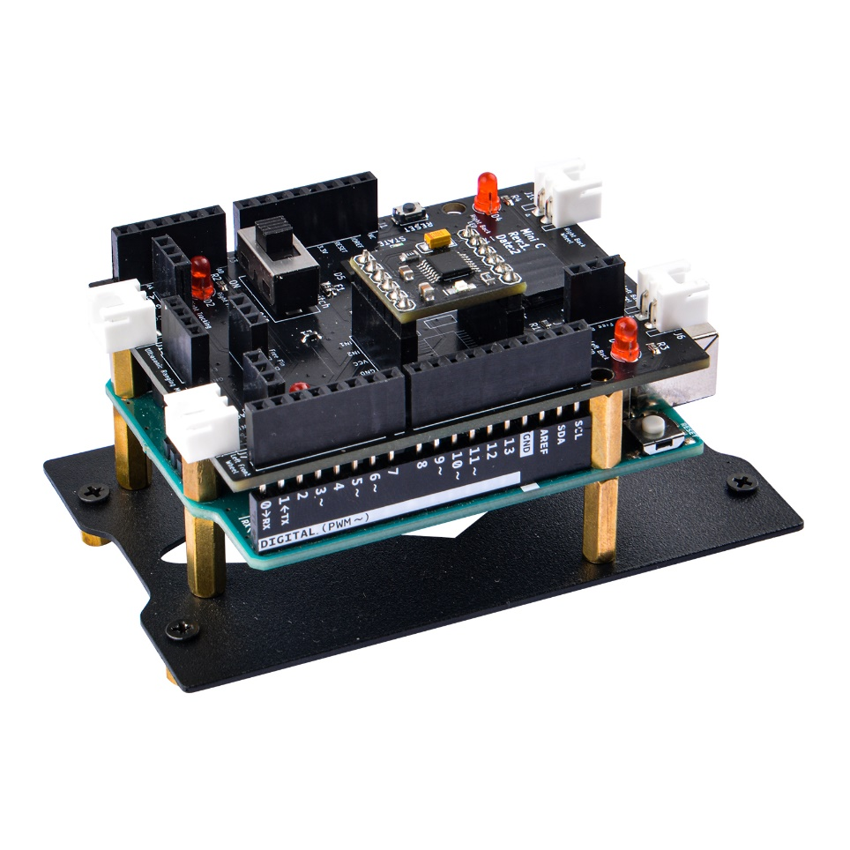

When installing the DRV8833 motor driver board, please pay attention to the installation direction. There is a silk screen on the expansion board that clearly shows the corresponding direction. **Please note that installation in the wrong direction may damage the driver board.**

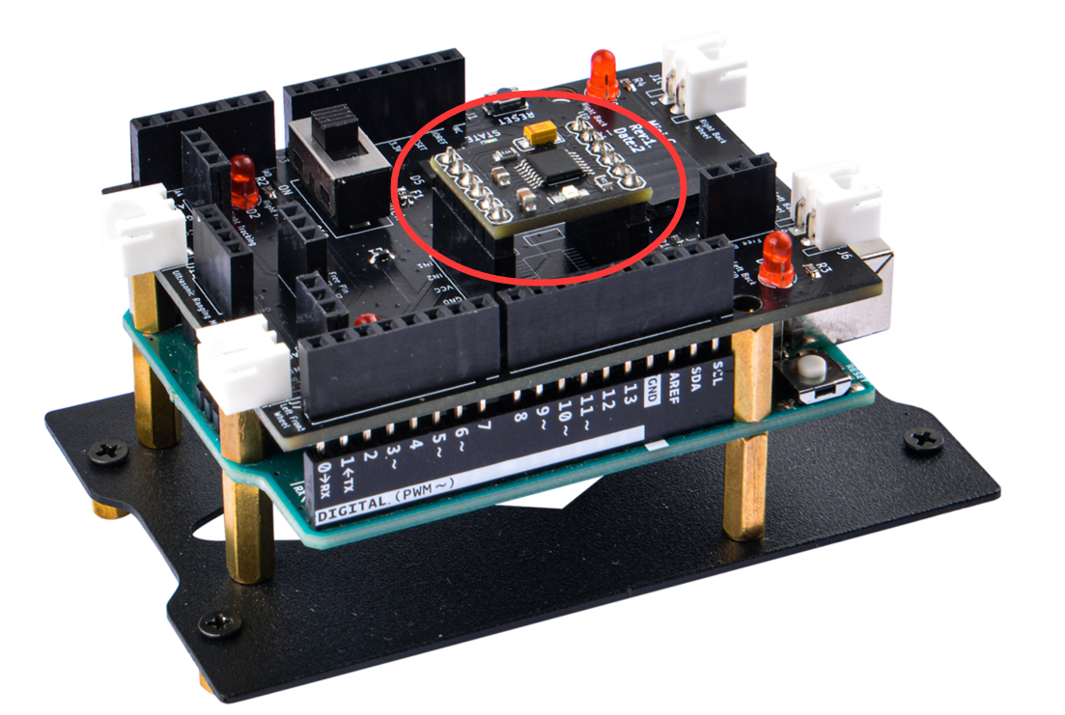

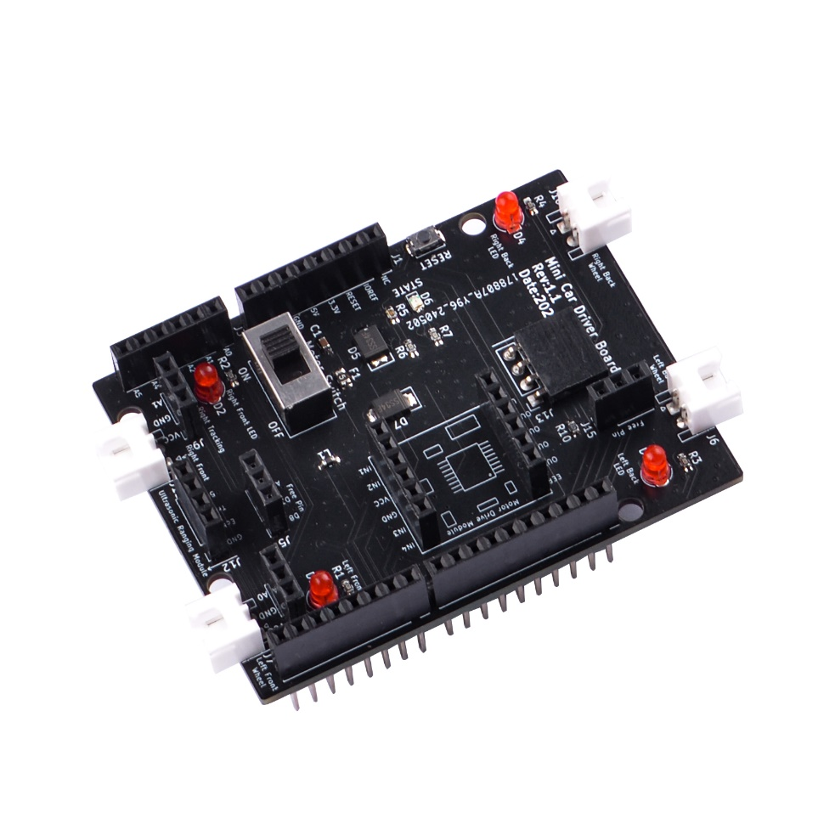

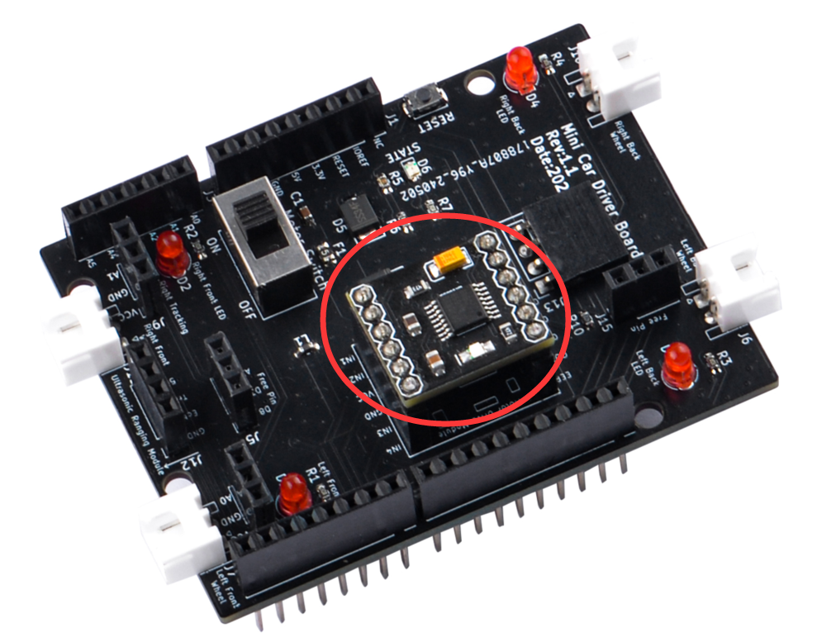

#### Step 3: Install line tracking module

Fix the double-through copper pillar to line tracking module with flat head M2.5 screw according to following figure

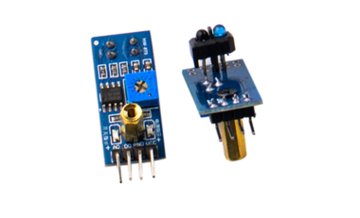

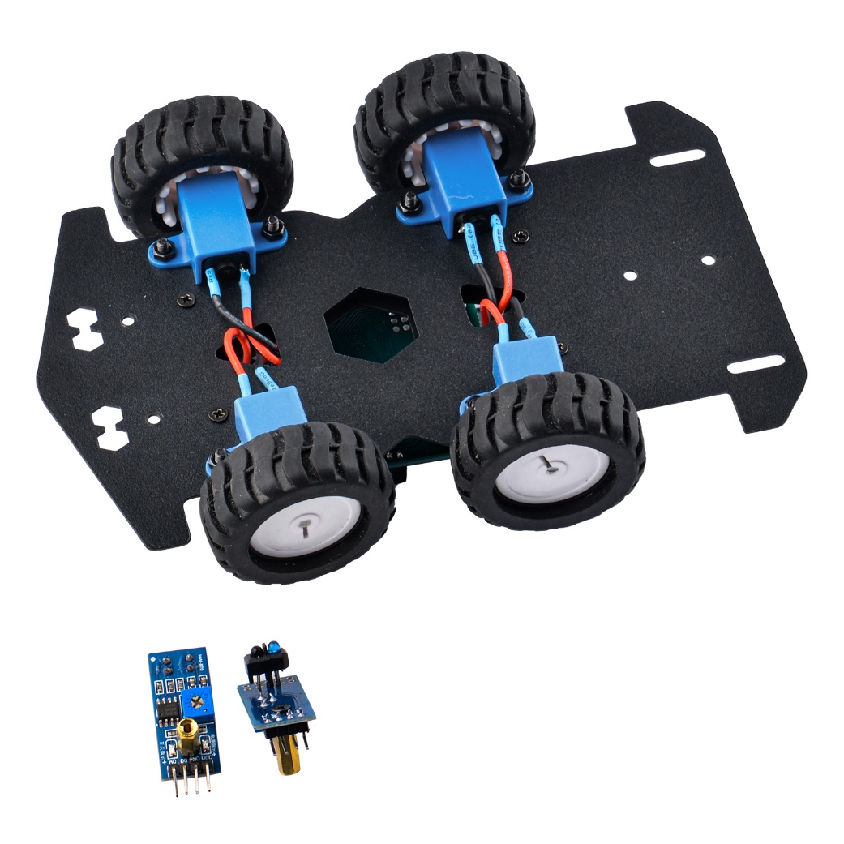

And then fix it to the chassis on following position, make sure it aligned straight to forward.

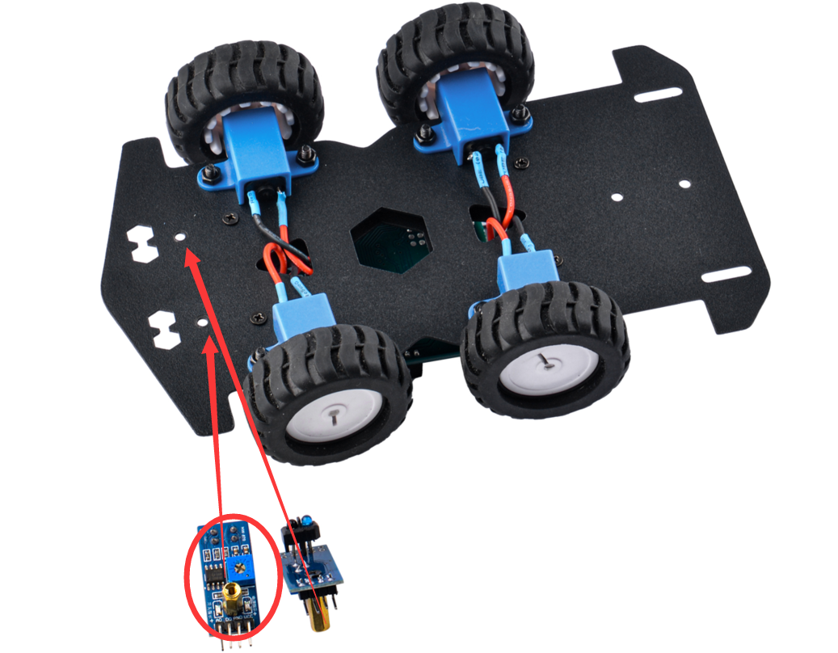

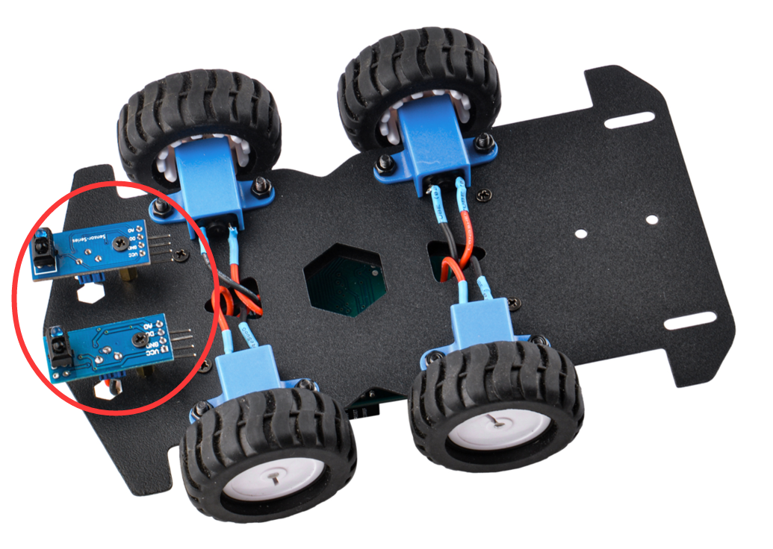

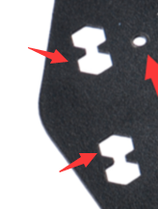

There are two holes for adjusting the potentiometer on the line tracking module.

Then find 6 male and female DuPont wires, connect the DuPont wires to the pins of the line tracking module, and connect them to VCC, GND, and AO respectively. Then pass the wire through the center hole of the base plate as following figure:

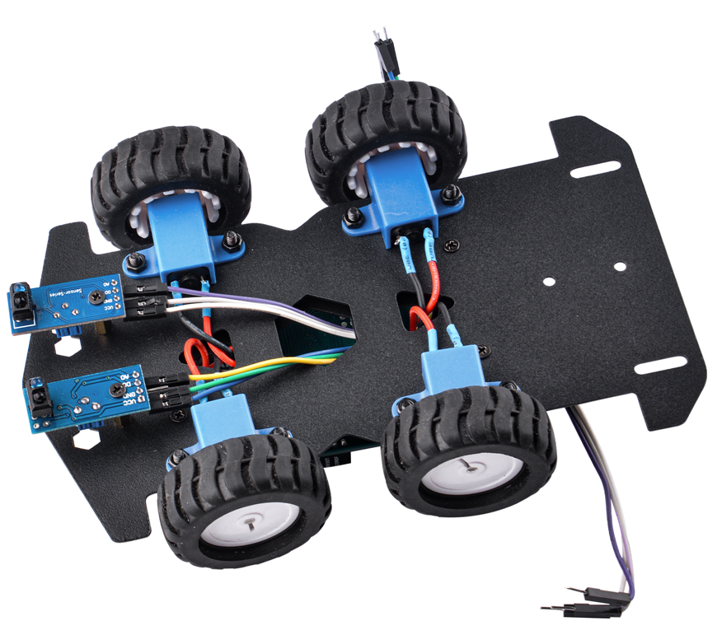

#### Step 4: Fixed host computer module

Fix the host computer to the base plate and find the battery box, Bluetooth module and ultrasonic module for spare use.

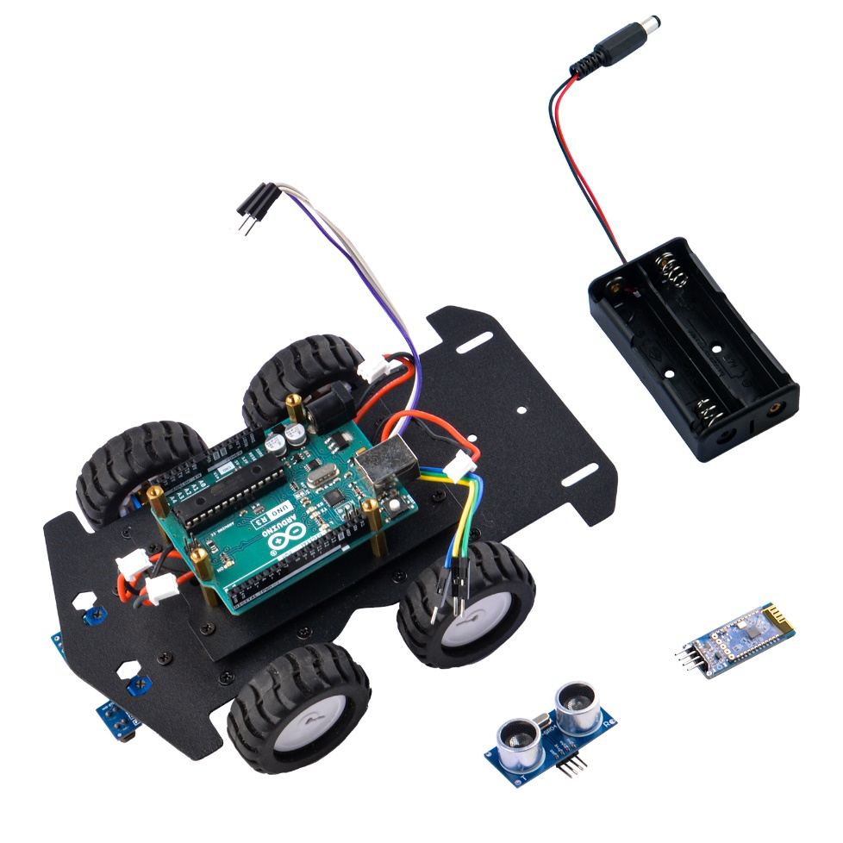

#### Step 5：Install the battery box

Use two screws and two nuts to fix the battery box to the bottom plate. Please keep the DC interface of the battery box close to the DC port of arduino UNO R3.

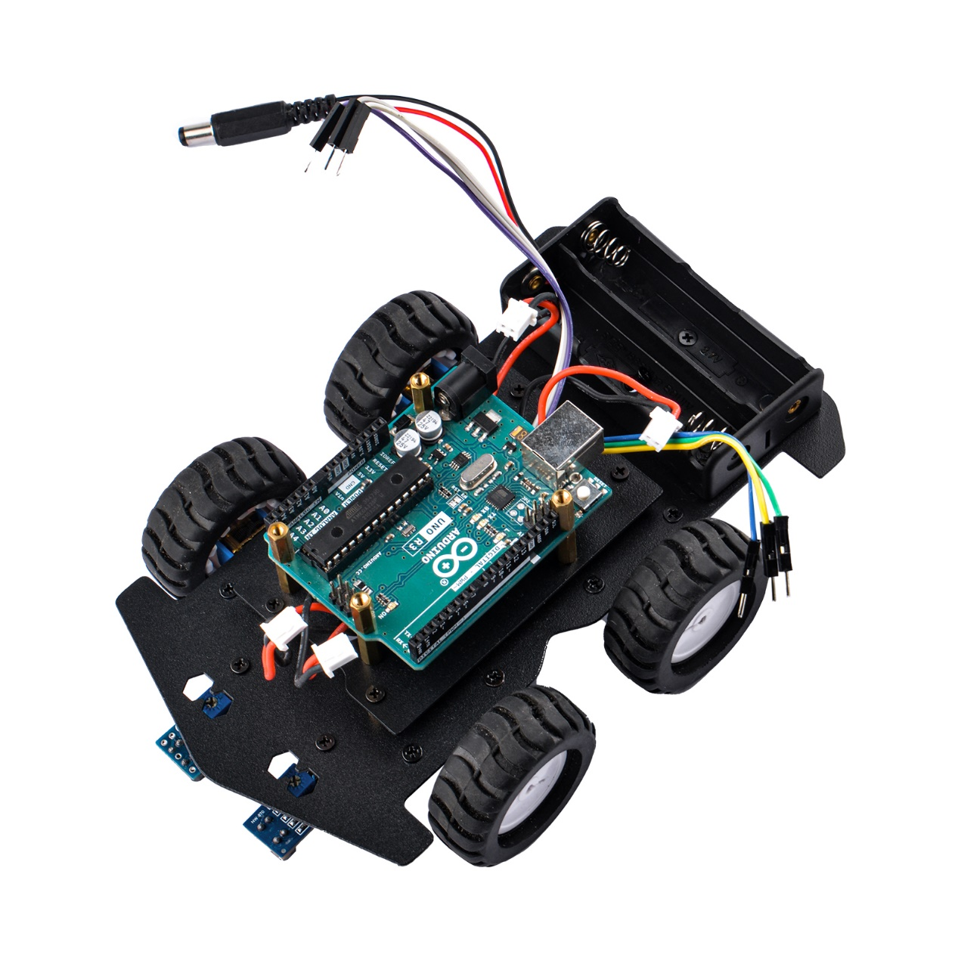

#### Step 6: Install the expansion board

Insert the expansion board into Arduino UNO R3 and secure it with M2.5 flat head screws.

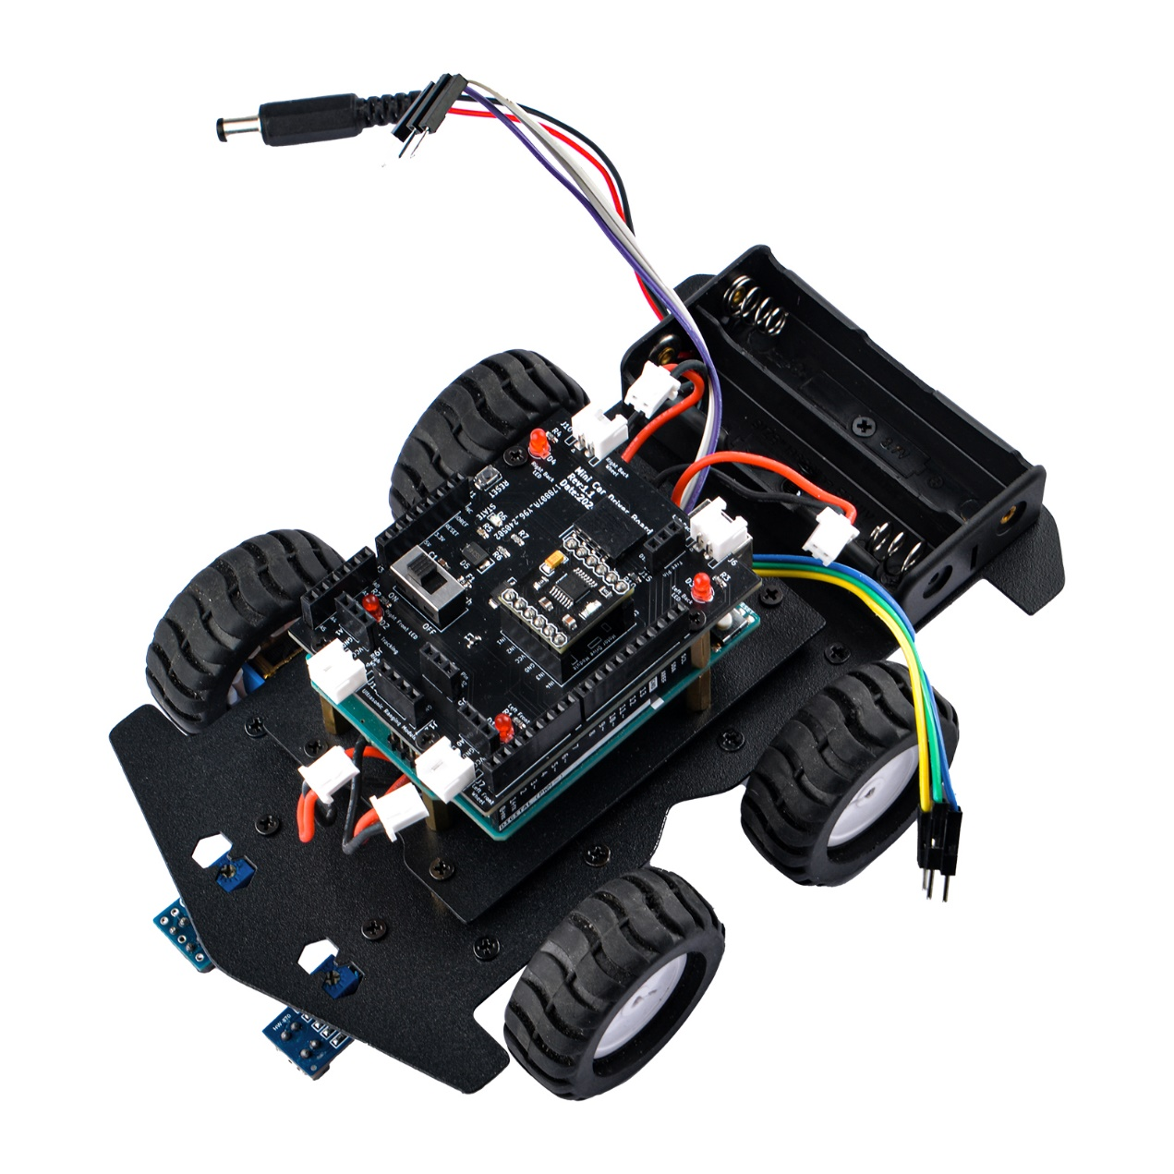

#### Step 7: Connect the motor cable to expansion board.

Please pay attention to the order of the motor interfaces, carefully observe the motor power pins, the red and black cables, the left and right sides are opposite. If the installation is wrong, it may cause the motor to rotate reversely during program debugging. If the installation is incorrect, you can remove the motor and reinstall it.

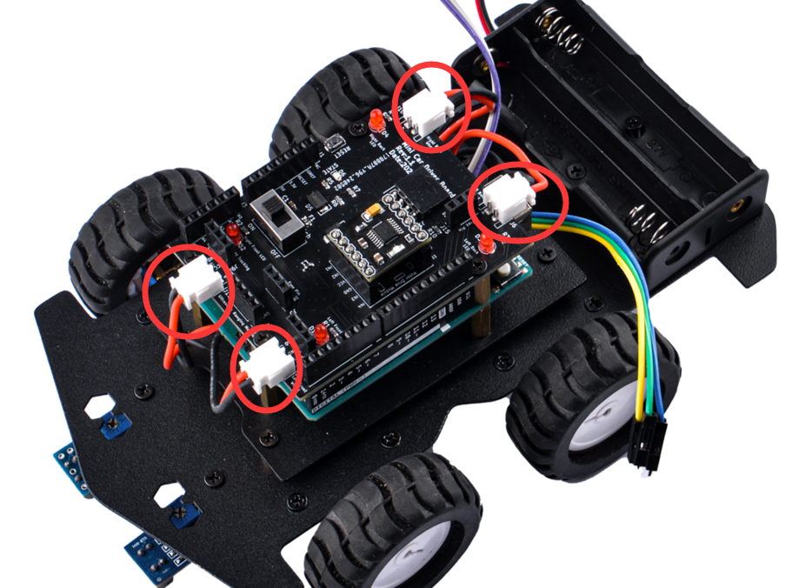

#### Step 8: Connect the Dupong wire to expansion board

Please pay attention to the silk screen on the expansion board, and connect the cable to the correct position. VCC is connected to the VCC of the line tracking module, GND is connected to GND, the tracking module on the left is connected to A0 of Arduino UNO R3, and the tracking module on the right is connected to Arduino A1 interface of UNO R3.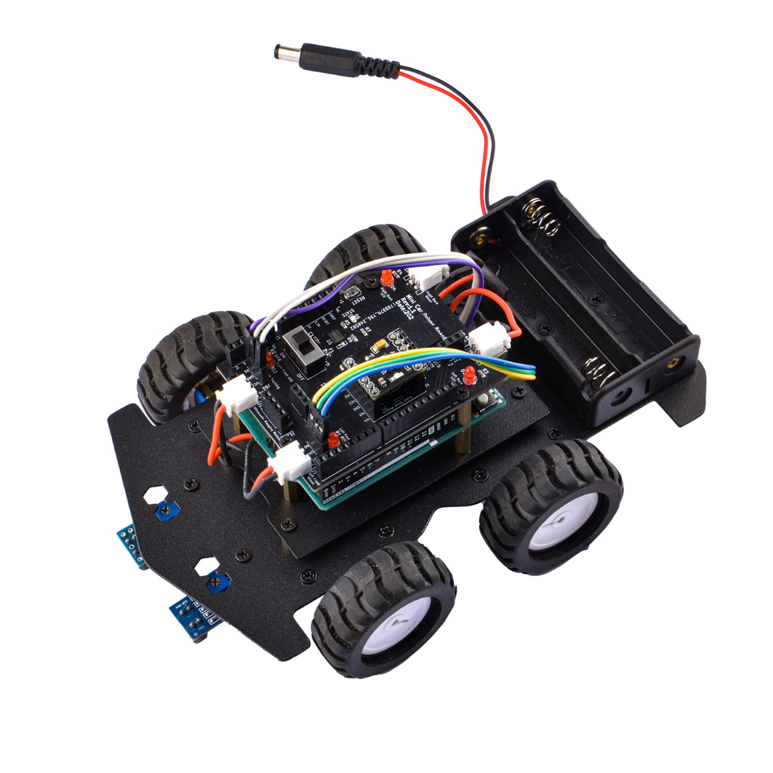

**NOTE: Please make sure the connection is correct to avoid incorrect connection or short circuit.**

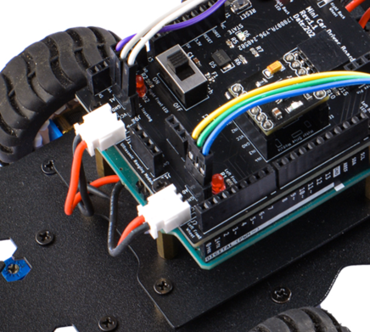

#### Step 9: Insert Bluetooth module

Please make sure insert bluetooth module as following figure.

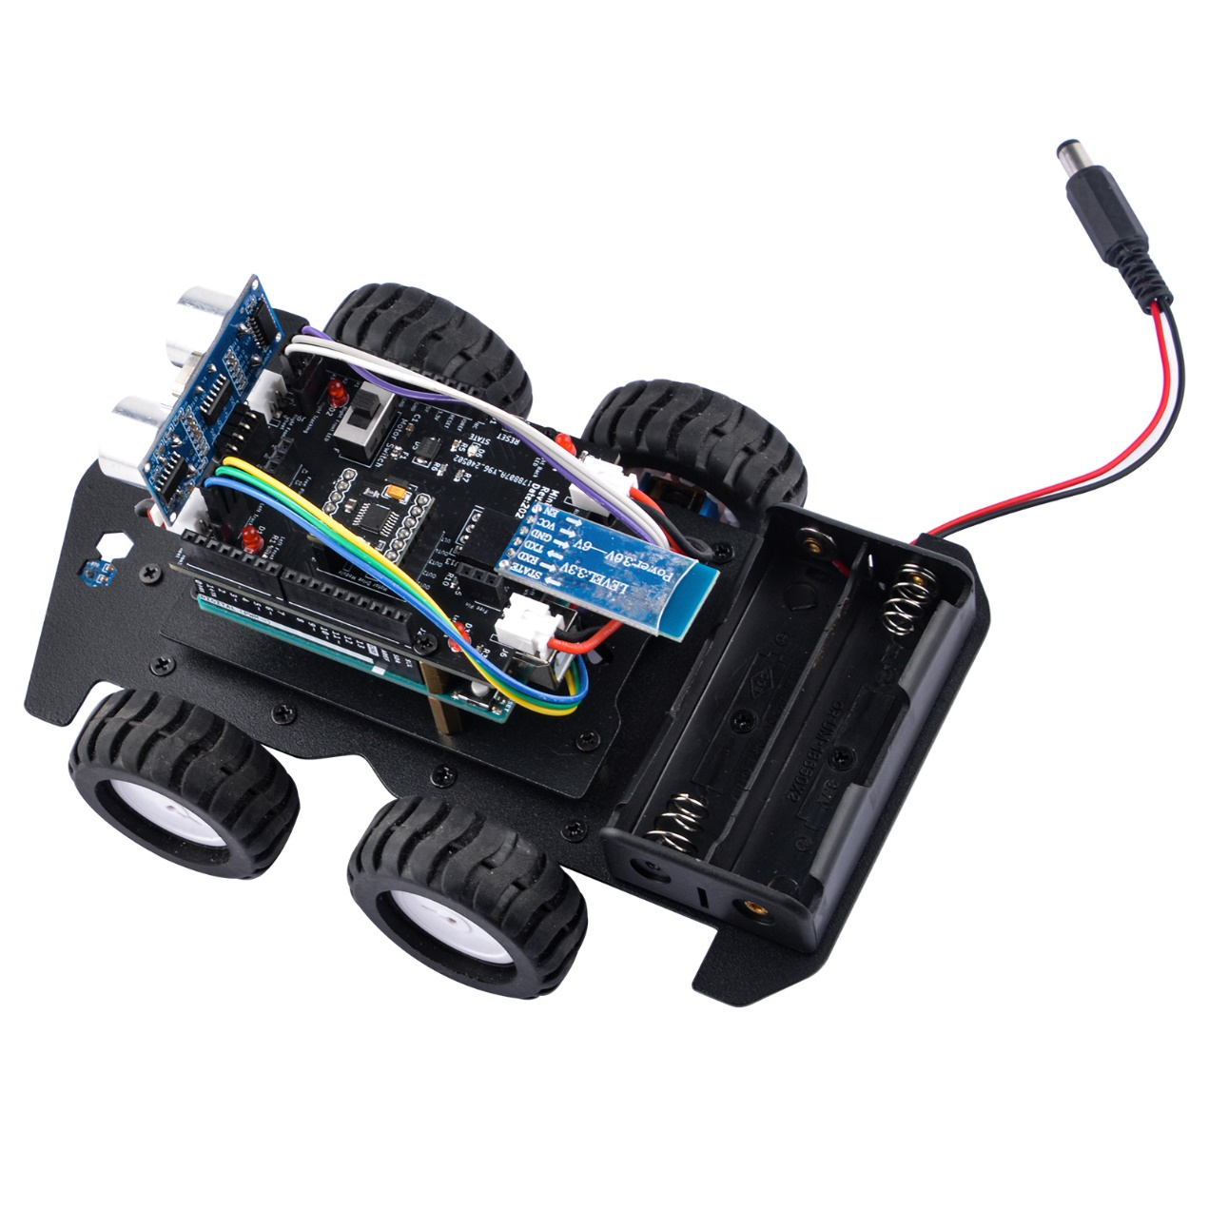

#### Step 10: Insert ultrasonic sensor

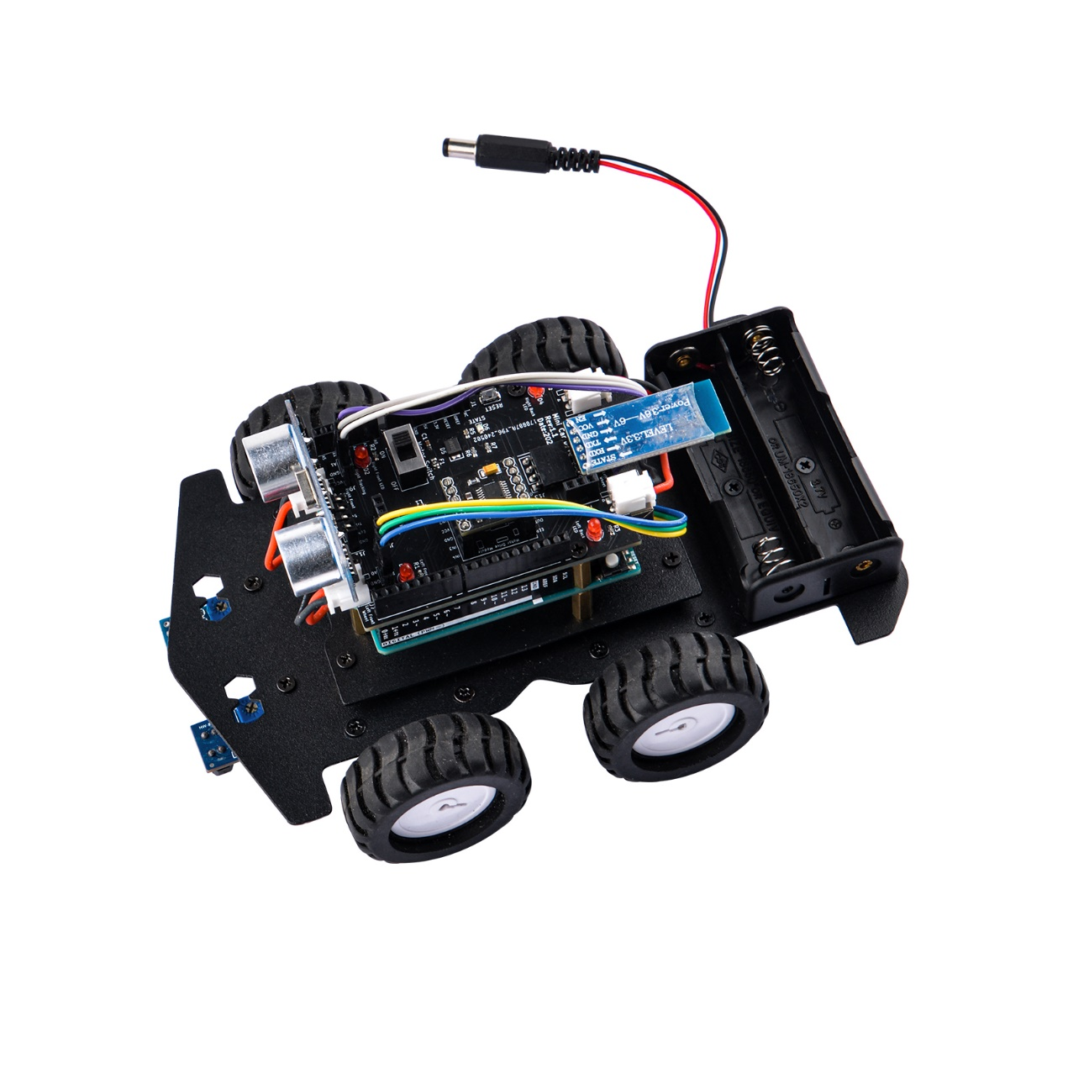

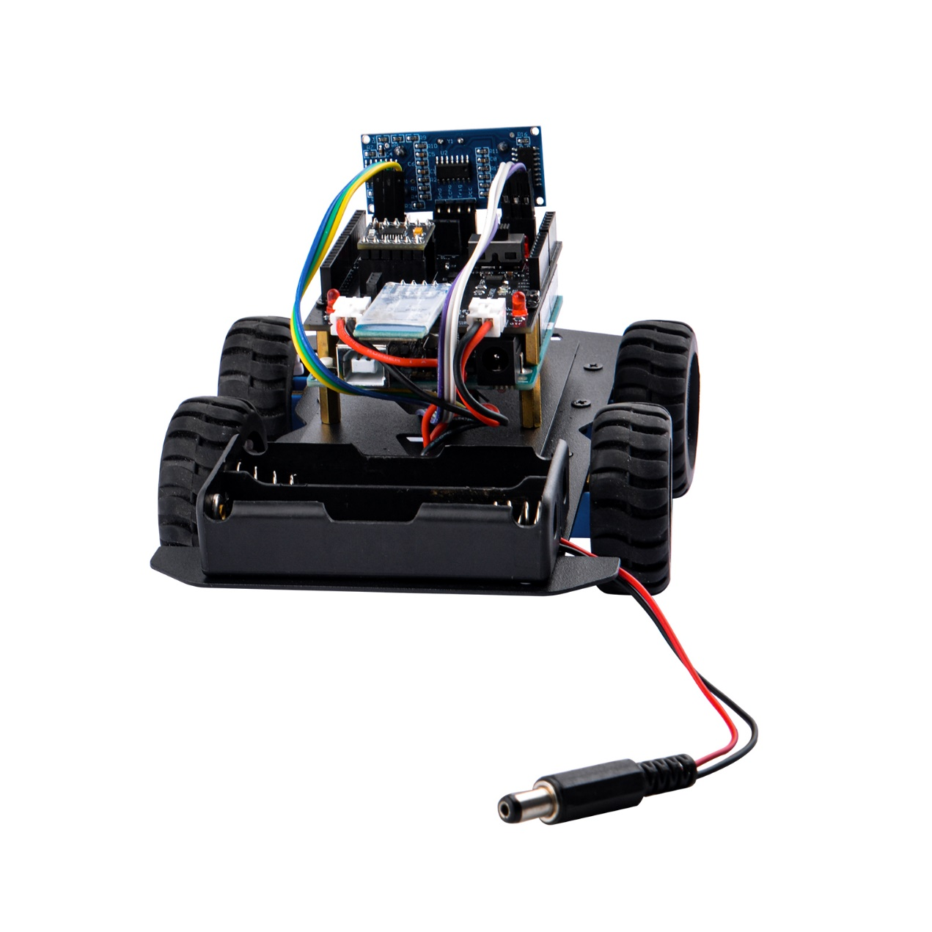

#### Step 11: Insert 18650 Li-po batteries

Please pay attention to the polarity when inserting the battery. You can refer to the direction in the battery box for installation. **Please note that incorrect installation may cause battery damage and equipment damage**

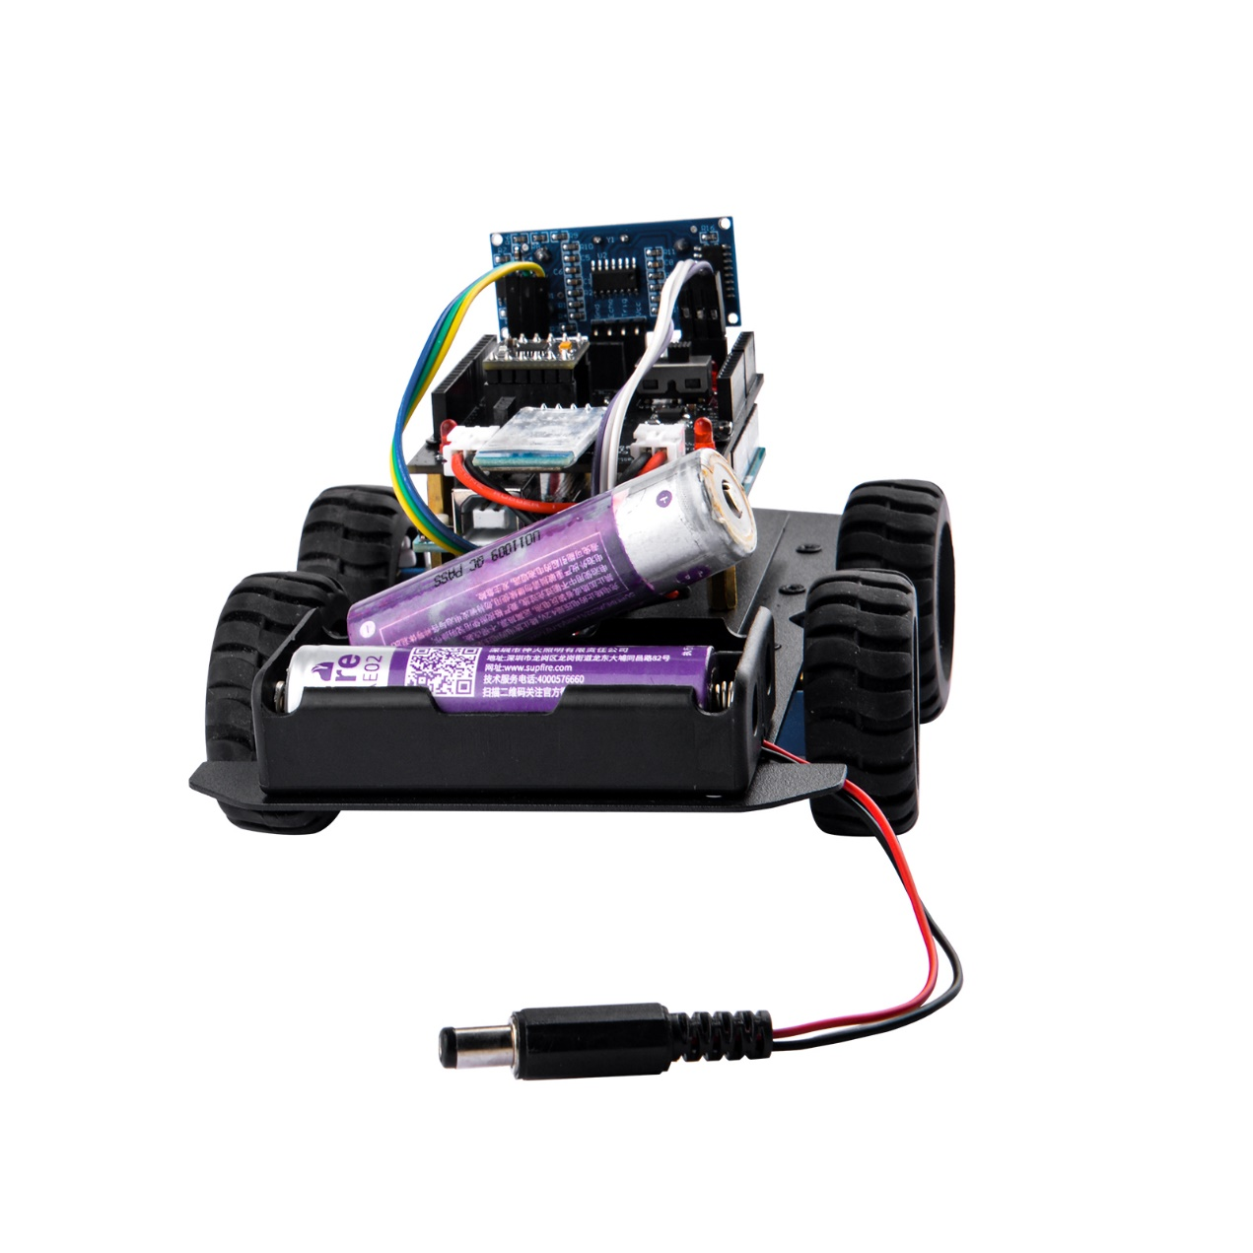

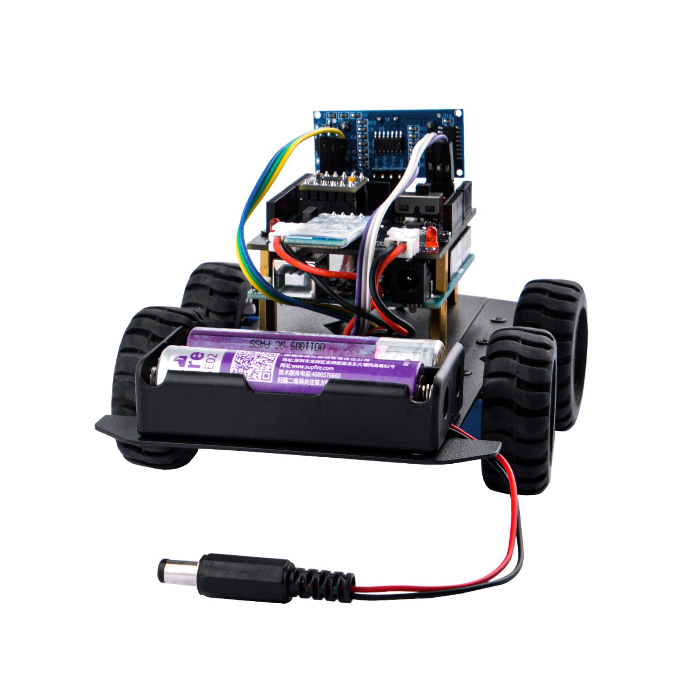

The installation of the hardware part is over here. You can go back to the computer for programming, uploading code and other operations. Let us continue!

### Install Arduino IDE

There are two ways to get the installation package:

* MicroSD card

There are plenty of materials inside the MicroSD card, Open the MicroSD card with card reader with PC or laptop, navigate to “Software” -> “Arduino_IDE_installer” folder, and then install Arduino IDE according to your own system platform. it contains installer for Windows, Linux, MacOS.

* Download from Internet

Please refer to following parts.

#### Installation instructions

**If you’re using a Chromebook, see Use Arduino with Chromebook.**

[**https://support.arduino.cc/hc/en-us/articles/360016495639-Use-Arduino-with-Chromebook**](https://support.arduino.cc/hc/en-us/articles/360016495639-Use-Arduino-with-Chromebook)

##### Windows

* Download the latest release (The download will start after you click this link：

<https://downloads.arduino.cc/arduino-ide/arduino-ide_latest_Windows_64bit.exe>

Check your browser’s download manager or the Downloads folder on your computer to find the downloaded file)

* Double-click the executable (.exe) file.
* Follow the instructions in the installation guide.
* When completing the setup, leave Run Arduino IDE ticked to launch the application, or launch it later from the Start Menu.

##### macOS

* Download the latest release (The download will start after you click this link.

<https://downloads.arduino.cc/arduino-ide/arduino-ide_latest_macOS_64bit.dmg>

Check your browser’s download manager or the Downloads folder on your computer to find the downloaded file)

* Double-click the disk image (.dmg) file.
* Drag and drop the Arduino IDE application into the Applications folder.
* Launch Arduino IDE the same way you would launch any other application (such as ⌘ + Space for Spotlight and search for “Arduino”).

##### Linux

* Download the latest release：

<https://downloads.arduino.cc/arduino-ide/arduino-ide_latest_Linux_64bit.AppImage>

* Find the **AppImage** file in your file manager.
* Make the **AppImage** file executable:

1. Right-click the file.

2. Choose Properties

3. Select the Permissions.

4. Tick the Allow executing file as program box.

* Double-click the AppImage file to launch Arduino IDE.

If Arduino IDE fails to open, and you see the text **dlopen(): error loading libfuse.so.2** or **AppImages require FUSE to run**, you may be missing some **dependencies[1]**. <https://support.arduino.cc/hc/en-us/articles/360019833020-Download-and-install-Arduino-IDE#fn1>

Follow these steps:

1. Open the Terminal application.

2. Enter this command:

**sudo apt-get -y install libfuse2**

3. Press **Enter** and wait for the process to complete.

4. Close the Terminal window.

5. Try launching Arduino IDE again by **double-clicking** the **AppImage** file.

##### Additional download options

For a portable installation on Windows or Linux, use a “ZIP file” option:

* ZIP file (Windows)
* ZIP file 64 bits (X86-64) (Linux)
* For more control in mass deployment, use the MSI installer package (Windows Installer) file.
* Nightly builds – preview incoming releases.
* IDE 1 (legacy)

View all download options on the Software page:

<https://www.arduino.cc/en/software>

##### If you need help

* Arduino IDE 2 runs on the following systems:
* **Windows**: Win 10 (64-bit) or newer
* **macOS**: 10.15: “Catalina” or newer, 64-bit
* **Linux**: 64-bit
* If you’re using a Chromebook, see Use Arduino with Chromebook.

<https://support.arduino.cc/hc/en-us/articles/360016495639-Use-Arduino-with-Chromebook>

* If you’re installing the legacy version, see these guides for Windows, macOS, Linux.

<https://docs.arduino.cc/software/ide-v1/tutorials/Windows>  
<https://www.arduino.cc/en/Guide/macOS>

<https://docs.arduino.cc/software/ide-v1/tutorials/Linux>

* Consider using the Cloud Editor (you’ll need to install the Arduino Create Agent).

<https://support.arduino.cc/hc/en-us/articles/360014869820-Install-the-Arduino-Create-Agent>

* Check the Installation & Troubleshooting category in the Arduino Forum.

<https://forum.arduino.cc/c/using-arduino/installation-troubleshooting/18>

##### For example:

###### Arduino IDE 2 Installation (Windows)

Install the Arduino Software (IDE) on Window

This document explains how to install the Arduino Software (IDE) on Windows machines.

Download the Arduino Software (IDE2)

Get the latest version from the [download page](https://www.arduino.cc/en/Main/Software). You can choose between the Installer (.exe) and the Zip packages. We suggest you use the first one that installs directly everything you need to use the Arduino Software (IDE2), including the drivers. With the Zip package you need to install the drivers manually. The Zip file is also useful if you want to create a [portable installation](https://arduino.cc/en/Guide/PortableIDE).

When the download finishes, proceed with the installation and please allow the driver installation process when you get a warning from the operating system.

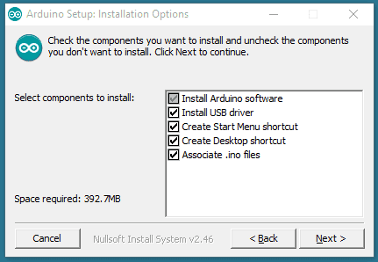

Choose the components to install.

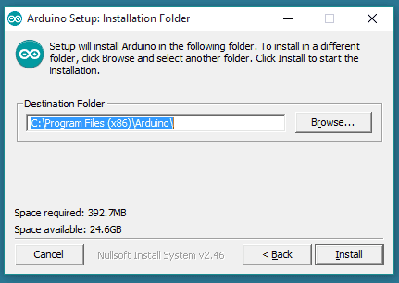

Choose the installation directory.

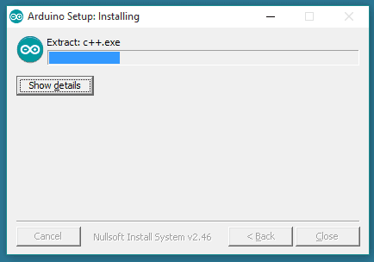

Installation in progress.

The process will extract and install all the required files to execute properly the Arduino Software (IDE)

### Install Libraries

Learn how to install additional libraries in the Arduino IDE 2.

Once you are comfortable with the Arduino software and using the built-in functions, you may want to extend the ability of your Arduino with additional libraries.

#### What are Libraries?

Libraries are a collection of code that makes it easy for you to connect to a sensor, display, module, etc. For example, the LiquidCrystal library makes it easy to talk to character LCD displays.

There are thousands of libraries available for download directly through the Arduino IDE, and you can find all of them listed at the Arduino Library Reference.

#### Using the Library Manager

To install a new library into your Arduino IDE you can use the Library Manager. Open the IDE and click to the "Sketch" menu and then **Include Library > Manage Libraries**.

Then the Library Manager will open and you will find a list of libraries that are already installed or ready for installation. In this example we will install the Bridge library. Scroll the list to find it, click on it, then select the version of the library you want to install. Sometimes only one version of the library is available. If the version selection menu does not appear, don't worry: it is normal.

Finally click on install and wait for the IDE to install the new library. Downloading may take time depending on your connection speed. Once it has finished, an Installed tag should appear next to the Bridge library. You can close the library manager.

You can now find the new library available in the Sketch > Include Library menu. If you want to add your own library to Library Manager, follow these instructions.

<https://github.com/arduino/library-registry#adding-a-library-to-library-manager>

#### Importing a .zip Library

Libraries are often distributed as a ZIP file or folder. The name of the folder is the name of the library. Inside the folder will be a .cpp file, a .h file and often a keywords.txt file, examples folder, and other files required by the library. Starting with version 1.0.5, you can install 3rd party libraries in the IDE. Do not unzip the downloaded library, leave it as is.

In the Arduino IDE, navigate to **Sketch > Include Library > Add .ZIP Library**. At the top of the drop down list, select the option to "**Add .ZIP Library'**'.

You will be prompted to select the library you would like to add. Navigate to the .zip file's location and open it.

Return to the **Sketch > Include Library** menu. menu. You should now see the library at the bottom of the drop-down menu. It is ready to be used in your sketch. The zip file will have been expanded in the libraries folder in your Arduino sketches directory.

NB: The Library will be available to use in sketches, but with older IDE versions examples for the library will not be exposed in the ***File > Examples*** until after the IDE has restarted.

#### Manual Installation

When you want to add a library manually, you need to download it as a ZIP file, expand it and put in the proper directory. The ZIP file contains all you need, including usage examples if the author has provided them. The library manager is designed to install this ZIP file automatically as explained in the former chapter, but there are cases where you may want to perform the installation process manually and put the library in the libraries folder of your sketchbook by yourself.

You can find or change the location of your sketchbook folder at File > Preferences > Sketchbook location.

Go to the directory where you have downloaded the ZIP file of the library

Extract the ZIP file with all its folder structure in a temporary folder, then select the main folder, that should have the library name

Copy it in the "libraries" folder inside your sketchbook.

Start the Arduino Software (IDE), go to Sketch > Include Library. Verify that the library you just added is available in the list.

Please **note**: Arduino libraries are managed in three different places: inside the IDE installation folder, inside the core folder and in the libraries folder inside your sketchbook. The way libraries are chosen during compilation is designed to allow the update of libraries present in the distribution. This means that placing a library in the "libraries" folder in your sketchbook overrides the other libraries versions.

The same happens for the libraries present in additional cores installations. It is also important to note that the version of the library you put in your sketchbook may be lower than the one in the distribution or core folders, nevertheless it will be the one used during compilation. When you select a specific core for your board, the libraries present in the core's folder are used instead of the same libraries present in the IDE distribution folder.

Last, but not least important is the way the Arduino Software (IDE) upgrades itself: all the files in Programs/Arduino (or the folder where you installed the IDE) are deleted and a new folder is created with fresh content. This is why we recommend that you only install libraries to the sketchbook folder so they are not deleted during the Arduino IDE update process.

### Arduino IDE 2 Overview

#### Overview

The Arduino IDE 2 features a new sidebar, making the most commonly used tools more accessible.

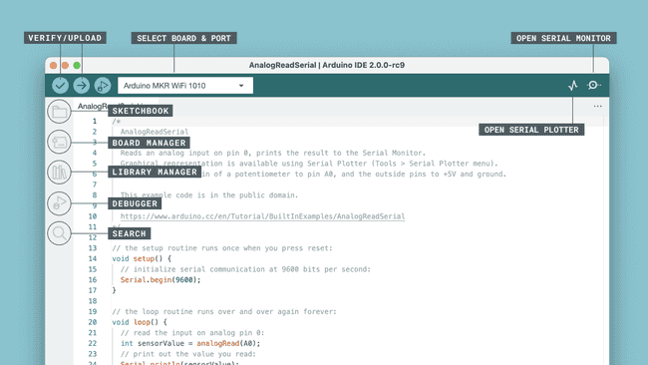Arduino IDE 2

* **Verify / Upload** - compile and upload your code to your Arduino Board.
* **Select Board & Port** - detected Arduino boards automatically show up here, along with the port number.
* **Sketchbook** - here you will find all of your sketches locally stored on your computer. Additionally, you can sync with the [Arduino Cloud](https://cloud.arduino.cc/), and also obtain your sketches from the online environment.
* **Boards Manager** - browse through Arduino & third party packages that can be installed. For example, using a MKR WiFi 1010 board requires the Arduino SAMD Boards package installed.
* **Library Manager** - browse through thousands of Arduino libraries, made by Arduino & its community.
* **Debugger** - test and debug programs in real time.
* **Search** - search for keywords in your code.
* **Open Serial Monitor** - opens the Serial Monitor tool, as a new tab in the console.

#### Features

The Arduino IDE 2 is a versatile editor with many features. You can install libraries directly, sync your sketches with Arduino Cloud, debug your sketches and much more. In this section, some of the core features are listed, along with a link to a more detailed article.

##### Sketchbook

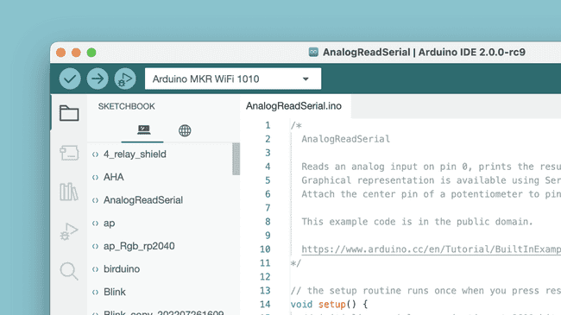Arduino Sketchbook.

Your sketchbook is where your code files are stored. Arduino sketches are saved as .ino

 files, and must be stored in a folder of the exact name. For example, a sketch named my_sketch.ino must be stored in a folder named my_sketch. Typically, your sketches are saved in a folder named Arduino in your Documents folder.

To access your sketchbook, click on the **folder icon** located in the sidebar.

##### Boards Manager

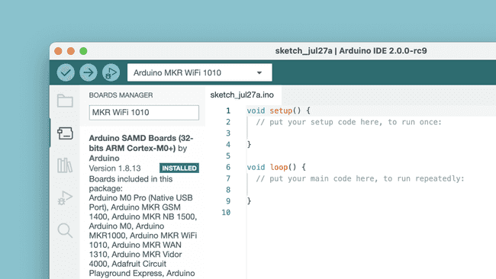Boards Manager.

With the Boards Manager, you can browse and install board packages. A board package contains the "instructions" for compiling your code to the boards that are included in the board package.

There are several Arduino board packages available, such as **avr, samd, megaavr** and more.

To learn more about the Boards Manager, visit the Installing new boards tutorial.

<https://docs.arduino.cc/software/ide-v2/tutorials/ide-v2-board-manager>

##### Library Manager

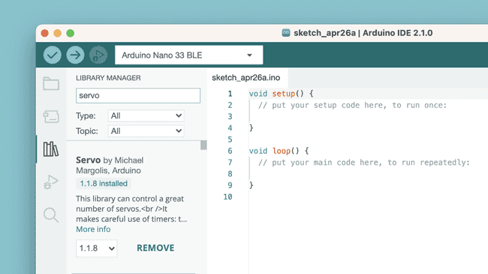Library Manager.

With the library manager you can browse and install thousands of libraries. Libraries are extensions of the Arduino API, and makes it easier to for example control a servo motor, read specific sensors, or use a Wi-Fi module.

To learn more about the library manager, visit the Installing libraries tutorial.

<https://docs.arduino.cc/software/ide-v2/tutorials/ide-v2-installing-a-library>

##### Serial Monitor

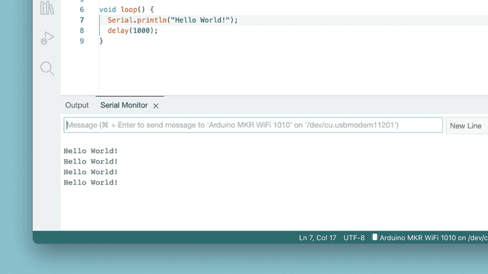Serial Monitor.

The Serial Monitor is a tool that allows you to view data streaming from your board, via for example the **Serial.print()** command.

Historically, this tool has been located in a separate window, but is now integrated with the editor. This makes it easy to have multiple instances running at the same time on your computer.

To learn more about the Serial Monitor, visit the [Serial Monitor tutorial](https://docs.arduino.cc/software/ide-v2/tutorials/ide-v2-serial-monitor).

<https://docs.arduino.cc/software/ide-v2/tutorials/ide-v2-serial-monitor>

##### Serial Plotter



The Serial Plotter tool is great for visualizing data using graphs, and to monitor for example peaks in voltage.

You can monitor several variables simultaneously, with options to enable only certain types.

To learn more about the Serial Plotter, visit the Serial Plotter tutorial.

<https://docs.arduino.cc/software/ide-v2/tutorials/ide-v2-serial-plotter>

##### Example Sketches

An important part of the Arduino Documentation are the example sketches that come bundled with libraries. They will show examples of the functions used in practice, illustrating the intended use and features of a library.

Libraries that come bundled as a part of a boards package may also include libraries, and those libraries often include example sketches.

To open the example sketches bundled in either the libraries you have installed manually or that come bundled in board packages, navigate to **File > Examples** and find the library you're searching for in the list that appears.

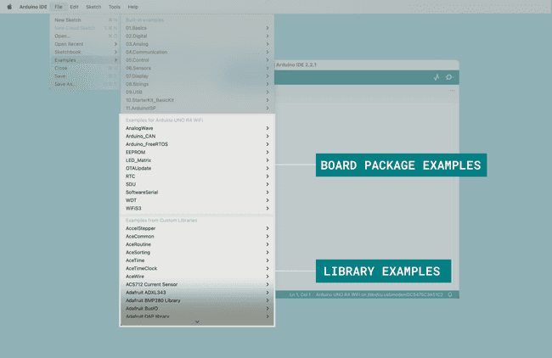

In the image above, you can see what the examples list looks like when a UNO R4 WiFi board is connected to your computer.

From here, you can for example navigate to File > Examples > LED_Matrix > MatrixIntro and upload the sketch to your board to show the Tetris animation that came pre-loaded on your UNO R4 WiFi when you first took it out of its box.

##### Debugging



The debugger tool is used to test and debug programs, hence the name. It can be used to navigate through a program's execution in a controlled manner.

To learn more about the debugger tool, visit the Debugging tutorial.

<https://docs.arduino.cc/software/ide-v2/tutorials/ide-v2-debugger>

### How to make Car running?

#### Hardware

Please make sure you have already assemble the whole car chassis and arduino UNO R3 and expansion board.

#### Software

After installing arduino IDE, open Arduino IDE 2 by click the icon on desktop, and create a new sketch or just open the demo code from the MicroSD card which is coming with the package.

**NOTE:**

**Demo code locate to the folder “Democodes” inside the MicroSD card.**

OK, here we are going to begin with an empty sketch.

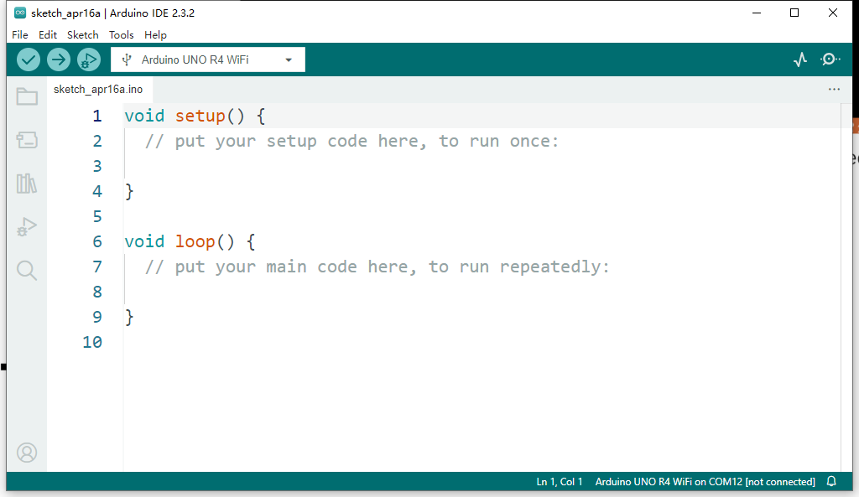

The "empty sketch" refers to the simplest form of an Arduino sketch, which typically includes only the two required functions: **setup() and loop().**

Here's what these functions do:

* **setup() function:** This function is called once when the Arduino board is powered up or reset. It is used for initializing variables, setting pin modes, and other initial setup tasks. Anything inside this function will run only once at the beginning of the program.
* **loop() function:** After the setup() function completes, the loop() function runs continuously in a loop as long as the Arduino is powered on. It is where you put the main logic of your program, such as reading sensors, controlling outputs, or performing calculations. Whatever code is inside the loop() function will execute repeatedly until the Arduino is powered off or reset.

#### Demo code:

I'll guide you through a piece of code before explaining its purpose. This approach allows you to engage directly with the code, whether by copying it into an Arduino sketch or by modifying it according to your own insights. By encouraging your active participation, I trust you'll develop a deeper understanding and potentially come up with innovative solutions.

Here is the demo code:

//DRV8833 Pinout

#define IN1 4

#define IN2 5

#define IN3 6

#define IN4 7

// // Ultrasonic sensor

// const int trigPin = 10;

// const int echoPin = 9;

// float duration, distance;

// led_LF - Left front LED, RF-right front, LB-Left back, RB-right back, by default connect to D2, A2, D12, D11.

const int led_LF = 2;

const int led_RF = A2;

const int led_LB = 12;

const int led_RB = 11;

// LEFT tracking module

// const int left_Track = A0;

// const int right_Track = A1;

// Android APP coding

#define SPINCW '6'

#define SPINCCW '5'

#define RIGHT '4'

#define LEFT '3'

#define BACK '2'

#define GO '1'

#define STOP '0'

//  turn left

void turnleft() {

  digitalWrite(IN1, HIGH);

  digitalWrite(IN2, LOW);

  digitalWrite(IN3, HIGH);

  digitalWrite(IN4, LOW);

}

// turn right

void turnright() {

  digitalWrite(IN1, LOW);

  digitalWrite(IN2, HIGH);

  digitalWrite(IN3, LOW);

  digitalWrite(IN4, HIGH);

}

// go ahead

void go() {

  digitalWrite(IN1, LOW);

  digitalWrite(IN2, HIGH);

  digitalWrite(IN3, HIGH);

  digitalWrite(IN4, LOW);

}

// go back

void back() {

  digitalWrite(IN1, HIGH);

  digitalWrite(IN2, LOW);

  digitalWrite(IN3, LOW);

  digitalWrite(IN4, HIGH);

}

// spinning in counter clockwise.

void spinCCW() {

  digitalWrite(IN1, LOW);

  digitalWrite(IN2, HIGH);

  digitalWrite(IN3, LOW);

  digitalWrite(IN4, HIGH);

}

// spinning in clockwise.

void spinCW() {

  digitalWrite(IN1, HIGH);

  digitalWrite(IN2, LOW);

  digitalWrite(IN3, HIGH);

  digitalWrite(IN4, LOW);

}

void initCar() {

  digitalWrite(IN1, LOW);

  digitalWrite(IN2, LOW);

  digitalWrite(IN3, LOW);

  digitalWrite(IN4, LOW);

}

// stop the car

void stopCar() {

  initCar();

}

// float get_distance() {

//   digitalWrite(trigPin, LOW);

//   delayMicroseconds(2);

//   digitalWrite(trigPin, HIGH);

//   delayMicroseconds(10);

//   digitalWrite(trigPin, LOW);

//   duration = pulseIn(echoPin, HIGH);

//   distance = (duration * 0.034) / 2;

//   return distance;

// }

void setup() {

  Serial.begin(9600);

  // Serial.println("Init ultrasonic sensor...");

  // pinMode(trigPin, OUTPUT);

  // pinMode(echoPin, INPUT);

  // delay(50);

  // Serial.println("Init ultrasonic sensor...OK!");

  Serial.println("Init DRV8833 driver...");

  pinMode(IN1, OUTPUT);

  pinMode(IN2, OUTPUT);

  pinMode(IN3, OUTPUT);

  pinMode(IN4, OUTPUT);

  delay(50);

  Serial.println("Init DRV8833 driver...OK!");

  Serial.println("Init LED...");

  pinMode(led_LF, OUTPUT);

  pinMode(led_RF, OUTPUT);

  pinMode(led_LB, OUTPUT);

  pinMode(led_RB, OUTPUT);

  delay(50);

  Serial.println("Init LED...OK!");

  Serial.println("Init Car functions...");

  initCar();

  delay(50);

  digitalWrite(led_LF, HIGH);

  digitalWrite(led_RF, HIGH);

  digitalWrite(led_LB, HIGH);

  digitalWrite(led_RB, HIGH);

  delay(1000);

  digitalWrite(led_LF, LOW);

  digitalWrite(led_RF, LOW);

  digitalWrite(led_LB, LOW);

  digitalWrite(led_RB, LOW);

  Serial.println("Car initializing finished!!!.");

}

char ch;

void loop() {

  // Serial.print("Currnet DISTANCE: ");

  // Serial.println(get_distance());

  if (Serial.available() > 0) {

    ch = Serial.read();

    if (ch == GO) {

      digitalWrite(led_LF, LOW);

      digitalWrite(led_RF, LOW);

      digitalWrite(led_RF, LOW);

      digitalWrite(led_RB, LOW);

      go();

      digitalWrite(led_LF, HIGH);

      digitalWrite(led_RF, HIGH);

    } else if (ch == BACK) {

      digitalWrite(led_LF, LOW);

      digitalWrite(led_RF, LOW);

      digitalWrite(led_RF, LOW);

      digitalWrite(led_RB, LOW);

      back();

      digitalWrite(led_LB, HIGH);

      digitalWrite(led_RB, HIGH);

    } else if (ch == RIGHT) {

      digitalWrite(led_LF, LOW);

      digitalWrite(led_RF, LOW);

      digitalWrite(led_RF, LOW);

      digitalWrite(led_RB, LOW);

      turnright();

      digitalWrite(led_LF, HIGH);

      digitalWrite(led_LB, HIGH);

    } else if (ch == LEFT) {

      digitalWrite(led_LF, LOW);

      digitalWrite(led_RF, LOW);

      digitalWrite(led_RF, LOW);

      digitalWrite(led_RB, LOW);

      turnleft();

      digitalWrite(led_RF, HIGH);

      digitalWrite(led_RB, HIGH);

    } else if (ch == STOP) {

      digitalWrite(led_LF, LOW);

      digitalWrite(led_RF, LOW);

      digitalWrite(led_RF, LOW);

      digitalWrite(led_RB, LOW);

      stopCar();

      digitalWrite(led_LF, LOW);

      digitalWrite(led_LB, LOW);

      digitalWrite(led_RF, LOW);

      digitalWrite(led_RB, LOW);

    } else if (ch == SPINCW) {

      digitalWrite(led_LF, LOW);

      digitalWrite(led_RF, LOW);

      digitalWrite(led_RF, LOW);

      digitalWrite(led_RB, LOW);

      spinCW();

      digitalWrite(led_LF, HIGH);

      digitalWrite(led_RB, HIGH);

    } else if (ch == SPINCCW) {

      digitalWrite(led_LF, LOW);

      digitalWrite(led_RF, LOW);

      digitalWrite(led_RF, LOW);

      digitalWrite(led_RB, LOW);

      spinCCW();

      digitalWrite(led_RF, HIGH);

      digitalWrite(led_LB, HIGH);

    }

  }

}

#### Explanations

Let's break it down:

Pin Definitions: The code defines the pins connected to the DRV8833 motor driver for controlling the motors' direction (IN1, IN2, IN3, IN4), as well as pins for controlling LEDs connected to the car.

##### Function Definitions:

turnleft(), turnright(), go(), back(), spinCCW(), spinCW(): These functions set the appropriate pins to control the motors to achieve the corresponding movement.

initCar(): This function initializes the motor driver pins to a neutral state (LOW).

stopCar(): This function stops the car by calling initCar().

There's also a commented-out function get_distance() which presumably was meant for reading data from an ultrasonic sensor, but it's not being used in the code.

##### Setup Function:

It initializes the serial communication for debugging purposes.

Initializes the pins for the motor driver, LEDs, and ultrasonic sensor (though the sensor-related code is commented out).

Initializes the car by calling initCar().

Flashes the LEDs to indicate initialization.

##### Loop Function:

It continuously checks for serial input. If there's serial data available, it reads it.

Depending on the received command (GO, BACK, RIGHT, LEFT, STOP, SPINCW, SPINCCW), it executes the corresponding movement function and controls the LEDs accordingly.

##### LED Control:

Before executing any movement, it turns off all LEDs.

After executing a movement, it turns on the appropriate LEDs to indicate the direction of movement.

Overall, the code allows controlling the robot car via serial commands, with visual feedback provided by LEDs. It's set up to respond to commands for moving forward, backward, turning left, turning right, stopping, and spinning clockwise/counterclockwise.

##### Details explanations:

Set the pin variables of the motor. The pins here are fixed according to the definition on the HAT board.

//DRV8833 Pinout

#define IN1 4

#define IN2 5

#define IN3 6

#define IN4 7

Define the encoding for communication with the Android APP. For example, SPINCW corresponds to the character 6, so when the Android APP sends the character 6 through Bluetooth, it means that the car needs to rotate clockwise. CW means clockwise.

// Android APP coding

#define SPINCW '6'

#define SPINCCW '5'

#define RIGHT '4'

#define LEFT '3'

#define BACK '2'

#define GO '1'

#define STOP '0'

Define LED indicators.

// led_LF - Left front LED, RF-right front, LB-Left back, RB-right back, by default connect to D2, A2, D12, D11.

const int led_LF = 2;

const int led_RF = A2;

const int led_LB = 12;

const int led_RB = 11;

Define the function module for the vehicle to move forward and backward, turn left, turn right, rotate clockwise in place, rotate counterclockwise in place, etc., which is convenient for calling in the main function. In addition, in actual operation, you can adjust the high and low levels of the pins To test, if you find that the direction of wheel rotation is incorrect, you can debug it according to the truth table of the previous DRV8833. Change the level to flip. If you find that the vehicle is not running correctly when using the current code. Please check whether the socket of the motor is installed correctly, or change the level mode of forward, backward, left turn, right turn in the code. It is a double H bridge. As long as the high and low levels of the opposite end are crossed, the motor can be driven to rotate.

//  turn left

void turnleft() {

  digitalWrite(IN1, HIGH);

  digitalWrite(IN2, LOW);

  digitalWrite(IN3, HIGH);

  digitalWrite(IN4, LOW);

}

// turn right

void turnright() {

  digitalWrite(IN1, LOW);

  digitalWrite(IN2, HIGH);

  digitalWrite(IN3, LOW);

  digitalWrite(IN4, HIGH);

}

// go ahead

void go() {

  digitalWrite(IN1, LOW);

  digitalWrite(IN2, HIGH);

  digitalWrite(IN3, HIGH);

  digitalWrite(IN4, LOW);

}

// go back

void back() {

  digitalWrite(IN1, HIGH);

  digitalWrite(IN2, LOW);

  digitalWrite(IN3, LOW);

  digitalWrite(IN4, HIGH);

}

// spinning in counter clockwise.

void spinCCW() {

  digitalWrite(IN1, LOW);

  digitalWrite(IN2, HIGH);

  digitalWrite(IN3, LOW);

  digitalWrite(IN4, HIGH);

}

// spinning in clockwise.

void spinCW() {

  digitalWrite(IN1, HIGH);

  digitalWrite(IN2, LOW);

  digitalWrite(IN3, HIGH);

  digitalWrite(IN4, LOW);

}

void initCar() {

  digitalWrite(IN1, LOW);

  digitalWrite(IN2, LOW);

  digitalWrite(IN3, LOW);

  digitalWrite(IN4, LOW);

}

// stop the car

void stopCar() {

  initCar();

}

Open the serial port, set the baud rate to 9600, initialize the output direction of the pin to the output direction, and initialize the car so that it cannot move, and at the same time, initialize the LED pins so that you can observe the car status at the very beginning.

void setup() {

  Serial.begin(9600);

  // Serial.println("Init ultrasonic sensor...");

  // pinMode(trigPin, OUTPUT);

  // pinMode(echoPin, INPUT);

  // delay(50);

  // Serial.println("Init ultrasonic sensor...OK!");

  Serial.println("Init DRV8833 driver...");

  pinMode(IN1, OUTPUT);

  pinMode(IN2, OUTPUT);

  pinMode(IN3, OUTPUT);

  pinMode(IN4, OUTPUT);

  delay(50);

  Serial.println("Init DRV8833 driver...OK!");

  Serial.println("Init LED...");

  pinMode(led_LF, OUTPUT);

  pinMode(led_RF, OUTPUT);

  pinMode(led_LB, OUTPUT);

  pinMode(led_RB, OUTPUT);

  delay(50);

  Serial.println("Init LED...OK!");

  Serial.println("Init Car functions...");

  initCar();

  delay(50);

  digitalWrite(led_LF, HIGH);

  digitalWrite(led_RF, HIGH);

  digitalWrite(led_LB, HIGH);

  digitalWrite(led_RB, HIGH);

  delay(1000);

  digitalWrite(led_LF, LOW);

  digitalWrite(led_RF, LOW);

  digitalWrite(led_LB, LOW);

  digitalWrite(led_RB, LOW);

  Serial.println("Car initializing finished!!!.");

}

Define the character variable **ch,** then enter the loop function, and then continuously judge the data content received by the serial port in the loop function. If the received character is 1, the corresponding operation is **GO**, and the **go** function will be called to operate the car to move forward. Others are also deduced in turn.

char ch;

void loop() {

  // Serial.print("Currnet DISTANCE: ");

  // Serial.println(get_distance());

  if (Serial.available() > 0) {

    ch = Serial.read();

    if (ch == GO) {

      digitalWrite(led_LF, LOW);

      digitalWrite(led_RF, LOW);

      digitalWrite(led_RF, LOW);

      digitalWrite(led_RB, LOW);

      go();

      digitalWrite(led_LF, HIGH);

      digitalWrite(led_RF, HIGH);

    } else if (ch == BACK) {

      digitalWrite(led_LF, LOW);

      digitalWrite(led_RF, LOW);

      digitalWrite(led_RF, LOW);

      digitalWrite(led_RB, LOW);

      back();

      digitalWrite(led_LB, HIGH);

      digitalWrite(led_RB, HIGH);

    } else if (ch == RIGHT) {

      digitalWrite(led_LF, LOW);

      digitalWrite(led_RF, LOW);

      digitalWrite(led_RF, LOW);

      digitalWrite(led_RB, LOW);

      turnright();

      digitalWrite(led_LF, HIGH);

      digitalWrite(led_LB, HIGH);

    } else if (ch == LEFT) {

      digitalWrite(led_LF, LOW);

      digitalWrite(led_RF, LOW);

      digitalWrite(led_RF, LOW);

      digitalWrite(led_RB, LOW);

      turnleft();

      digitalWrite(led_RF, HIGH);

      digitalWrite(led_RB, HIGH);

    } else if (ch == STOP) {

      digitalWrite(led_LF, LOW);

      digitalWrite(led_RF, LOW);

      digitalWrite(led_RF, LOW);

      digitalWrite(led_RB, LOW);

      stopCar();

      digitalWrite(led_LF, LOW);

      digitalWrite(led_LB, LOW);

      digitalWrite(led_RF, LOW);

      digitalWrite(led_RB, LOW);

    } else if (ch == SPINCW) {

      digitalWrite(led_LF, LOW);

      digitalWrite(led_RF, LOW);

      digitalWrite(led_RF, LOW);

      digitalWrite(led_RB, LOW);

      spinCW();

      digitalWrite(led_LF, HIGH);

      digitalWrite(led_RB, HIGH);

    } else if (ch == SPINCCW) {

      digitalWrite(led_LF, LOW);

      digitalWrite(led_RF, LOW);

      digitalWrite(led_RF, LOW);

      digitalWrite(led_RB, LOW);

      spinCCW();

      digitalWrite(led_RF, HIGH);

      digitalWrite(led_LB, HIGH);

    }

  }

}

#### Install APK file to android smart phone.

Because this car kit provides a Bluetooth module, you can remotely control the movement of the car by installing a Bluetooth app on your Android phone.

This is an open source app, you can download it from GitHub or just using the flash card(or maybe TF card) which is coming with the kit.

**Whether it is a USB flash drive or a TF card depends on the actual product you get.**

##### what to know

* Allow your browser to install APKs by going to Settings > Apps > Menu > Special access > Install unknown apps.
* Then, download the APK file and open it through the app you granted permission to. Install it normally.
* Alternatively, you can transfer the APK file from your computer over a USB connection.

##### Allow Unknown Apps on Android

* Before you can install an APK file through Chrome, Files by Google, a file manager, or any other app, you must give that app permission to do so. This is done through a toggle in the Settings app.
* Specific steps may differ based on the operating system version you're running, but the basic process will be the same.

###### 1. Open the Settings app and tap Apps or Apps & Notifications.

###### 2. Tap the three dots in the upper-right corner. If you don't see that, skip down to the next step.

###### 3. Tap Special access, or Special app access on some Android devices.

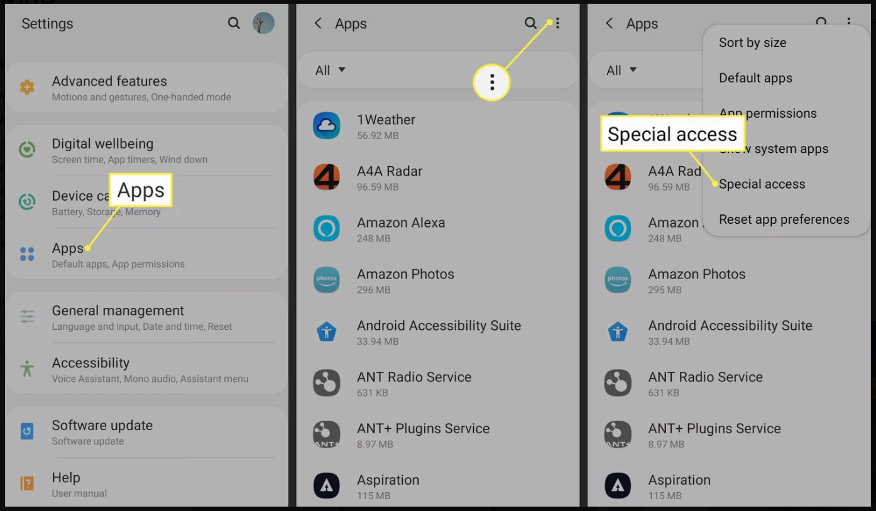

##### Install an APK File on Android

The easiest way to install an APK file on your Android is to download the file using the default browser, Chrome. Other web browsers definitely work, just make sure to give them the same permission described above. Here's how to install APK files through Chrome:

###### 1. On the download page for the APK file, simply tap the download option like you'd download any file.

**NOTE：** Only download APK files from reputable sources. A quick Google search can often let you know if an app (or company that makes the app) has a questionable reputation. We have some recommendations at the bottom of this page.

###### 2. Accept any prompts you might see about the file being potentially harmful. For example, tap Download anyway or OK.

###### 3. Once the APK is downloaded to your device, it's time to install the app. In Chrome, tap the three-dot menu button, then choose Downloads to see the file. You can also use a file manager if you prefer to install apps that way.

###### 4. Tap the file name followed by Install. After a few moments, the app will be fully installed and show up next to all your other apps.

##### Transfer the APK Installer via USB

If you don't have internet access on your phone, or for any other reason you can't use a browser to download the file, you can still install apps from your computer. Using your desktop web browser, download the APK file just like described above. Then, connect to your Android phone and transfer the file.

If you've never connected your Android to your computer, first [turn on USB debugging mode](https://www.lifewire.com/enable-usb-debugging-android-4690927).

<https://www.lifewire.com/enable-usb-debugging-android-4690927>

You can then plug your phone into your computer with a USB cable, and it'll mount the phone like it would a memory stick.

Your phone will show up as another drive in File Explorer. Move the APK file you downloaded into the appropriate folder on your phone, which might be called

**Download** or **/sdcard/download**, or an equivalent.

Once the file is transferred, use a file explorer app on your phone to tap the APK file and install the app.

The APK file for controlling the car can be downloaded from GITHUB or obtained directly from the USB flash drive that comes with the kit.

* Download APK file from GITHUB:

<https://github.com/geeekpi/pet_app/blob/master/apk/pet_app1.2.0.apk>

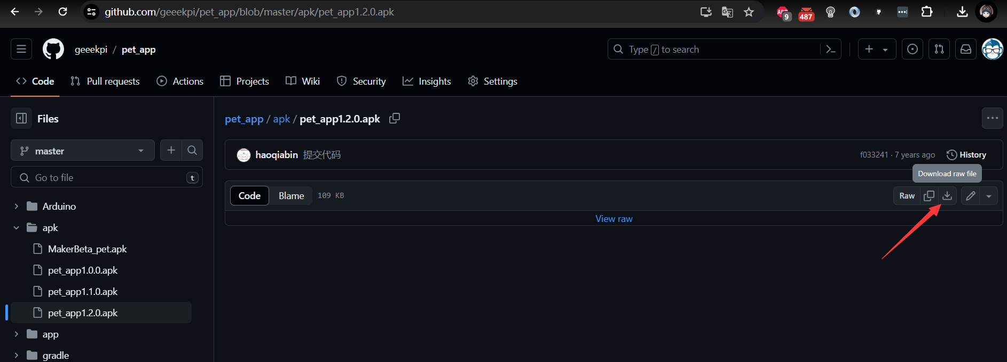

Source Code: https://github.com/geeekpi/pet_app

If you know how to develop Android yourself, you can try to modify and compile the APK file yourself.

* Install APK file, you can use ADB tool to install the APK file by typing following command in CMD prompt. (ADB tool required)

Refer to: https://beebom.com/how-to-install-adb-windows-mac/

After installation, you need to make sure it works properly, open a CMD prompt and typing:

**adb --version**

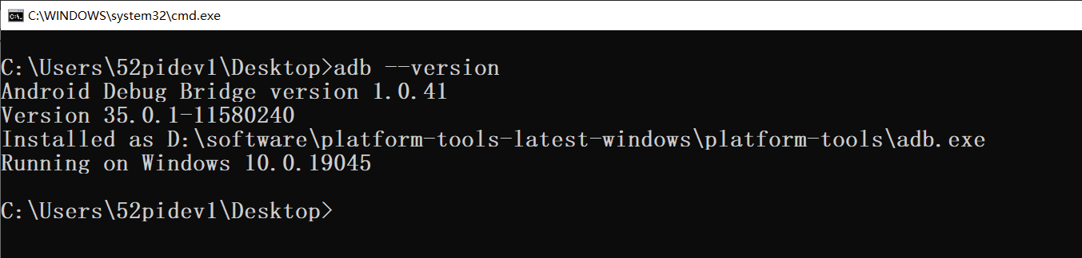

**It means it works fine.**

* Open a terminal and typing following command:

**adb devices**

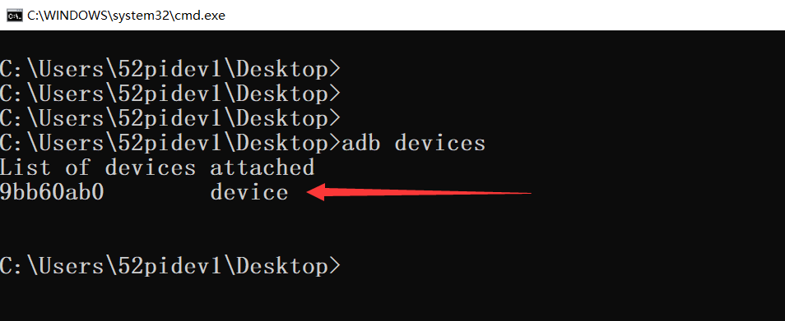

**It means one device is attached to your PC.**

* Install APK file by typing following command, we assume that I have already download the **pet_app1.2.0.apk file on location “Desktop” folder.**

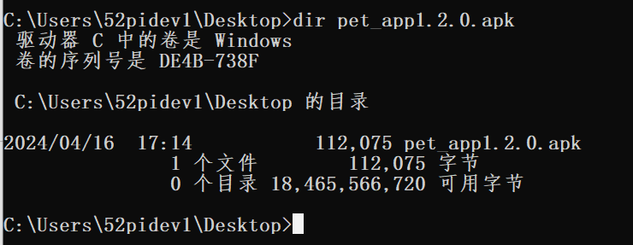

* Execute following command to install the APK file.

**adb install pet_app1.2.0.apk**

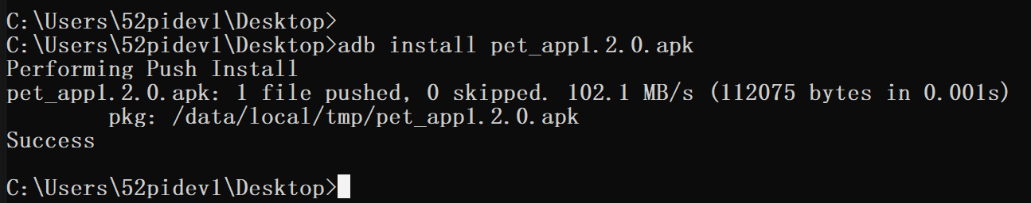

**Please make sure the right position of the APK file.**

* **If you want to remove the app, just execute following command:**

**adb uninstall cn.haoqiabin.pet**

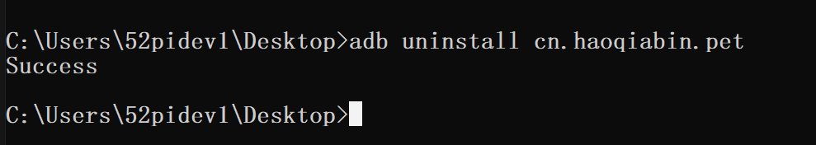

* **Open app and connect it to JYD-31-SPP Bluetooth module.**

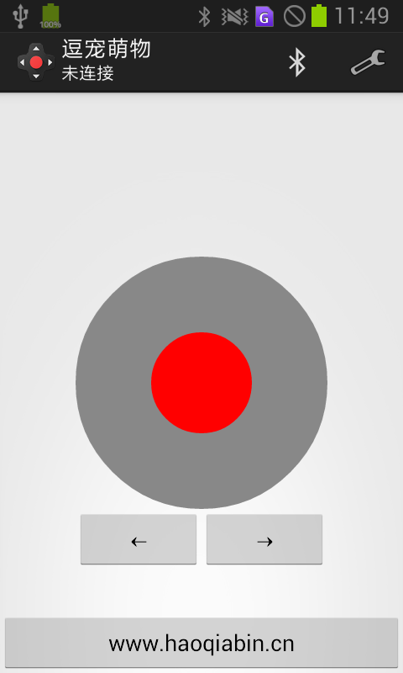

Click Bluetooth icon on right corner.

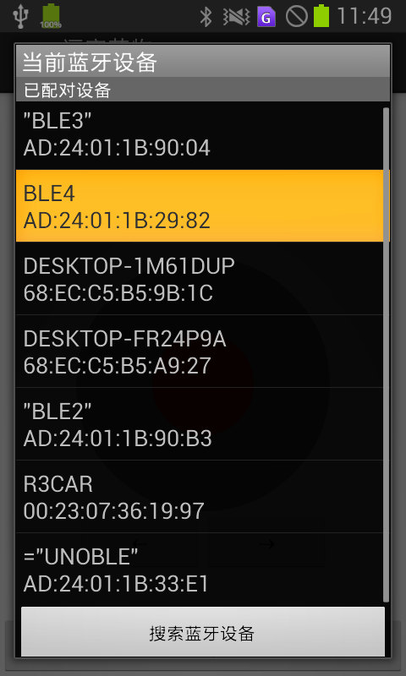

and then search broadcast name “JDY-31-SPP” and click connect to. it will pop up a message box and ask for password, use the default password of JDY-31 module, default password is 1234 and click connect.

**NOTE:** Please make sure you have already Setting the Bluetooth parameter before turn on the smart car.

### How to turn on LEDs?

Let's conduct a simple test first, using the most basic method to learn how to control LEDs with GPIO, before moving on to other experiments.

By Default, The LED indicators are connected to the pins on Arduino UNO R3:

|  |  |
| --- | --- |
| LED Indicators | Arduino UNO R3 |
| Left Front | D2 |
| Right Front | A2 |
| Left Back | D12 |
| Right Back | D11 |

* Initialize LED by creating variables and setting the pin direction as following demo code:

const int led_LF = 2;

const int led_RF = A2;

const int led_LB = 12;

const int led_RB = 11;

In setup() function section:

  pinMode(led_LF, OUTPUT);

  pinMode(led_RF, OUTPUT);

  pinMode(led_LB, OUTPUT);

  pinMode(led_RB, OUTPUT);

In loop() function section:

  digitalWrite(led_LF, HIGH);

  digitalWrite(led_RF, HIGH);

  digitalWrite(led_LB, HIGH);

  digitalWrite(led_RB, HIGH);

  delay(1000);

  digitalWrite(led_LF, LOW);

  digitalWrite(led_RF, LOW);

  digitalWrite(led_LB, LOW);

  digitalWrite(led_RB, LOW);

### How to detect obstacles ahead?

To detect obstacles ahead using an ultrasonic sensor, you can follow these steps:

* **Setup the Ultrasonic Sensor:** Connect the ultrasonic sensor to your microcontroller board (such as Arduino) following its datasheet or manufacturer's instructions. Typically, ultrasonic sensors have two pins for power (VCC and GND) and two pins for communication (TRIG and ECHO).
* **Understand Ultrasonic Principle:** Ultrasonic sensors work by emitting high-frequency sound waves and measuring the time it takes for the sound waves to bounce back after hitting an obstacle. The distance to the obstacle can then be calculated based on the time taken and the speed of sound.
* **Write the Code:**

1. Initialize the TRIG pin as an output and the ECHO pin as an input.

2. Send a short pulse on the TRIG pin to trigger the ultrasonic sensor.

3. Measure the duration for which the ECHO pin stays high. This duration corresponds to the 4. time taken for the sound wave to travel to the obstacle and back.

5. Convert this duration into distance using the speed of sound and the formula: distance = (duration / 2) * speed_of_sound.

* **Handle Obstacle Detection:**

1. Set a threshold distance beyond which an obstacle is considered to be detected.

2. Compare the measured distance with this threshold.

If the measured distance is less than the threshold, it indicates an obstacle is ahead.

* **Take Action:**

Once an obstacle is detected, you can program your microcontroller to take appropriate action, such as stopping the robot, reversing its direction, or turning to avoid the obstacle.

Repeat: Continuously repeat the above steps in a loop to constantly monitor for obstacles.

Here's a simple example code snippet using Arduino:

Default Pinout

|  |  |
| --- | --- |
| Arduino UNO R3 | Ultrasonic Sensor |
| 5V | VCC |
| GND | GND |
| D10 | TRIG |
| D9 | ECHO |

Demo Code:

//DRV8833 Pinout

#define IN1 4

#define IN2 5

#define IN3 6

#define IN4 7

// Ultrasonic sensor

const int trigPin = 10;

const int echoPin = 9;

float duration, distance;

//  turn left

void turnleft() {

  digitalWrite(IN1, HIGH);

  digitalWrite(IN2, LOW);

  digitalWrite(IN3, HIGH);

  digitalWrite(IN4, LOW);

}

// turn right

void turnright() {

  digitalWrite(IN1, LOW);

  digitalWrite(IN2, HIGH);

  digitalWrite(IN3, LOW);

  digitalWrite(IN4, HIGH);

}

// go ahead

void go() {

  digitalWrite(IN1, LOW);

  digitalWrite(IN2, HIGH);

  digitalWrite(IN3, HIGH);

  digitalWrite(IN4, LOW);

}

// go back

void back() {

  digitalWrite(IN1, HIGH);

  digitalWrite(IN2, LOW);

  digitalWrite(IN3, LOW);

  digitalWrite(IN4, HIGH);

}

// spinning in counter clockwise.

void spinCCW() {

  digitalWrite(IN1, HIGH);

  digitalWrite(IN2, LOW);

  digitalWrite(IN3, LOW);

  digitalWrite(IN4, HIGH);

}

// spinning in clockwise.

void spinCW() {

  digitalWrite(IN1, HIGH);

  digitalWrite(IN2, LOW);

  digitalWrite(IN3, HIGH);

  digitalWrite(IN4, LOW);

}

void initCar() {

  digitalWrite(IN1, LOW);

  digitalWrite(IN2, LOW);

  digitalWrite(IN3, LOW);

  digitalWrite(IN4, LOW);

}

// stop the car

void stopCar() {

  initCar();

}

float get_distance() {

  digitalWrite(trigPin, LOW);

  delayMicroseconds(2);

  digitalWrite(trigPin, HIGH);

  delayMicroseconds(10);

  digitalWrite(trigPin, LOW);

  duration = pulseIn(echoPin, HIGH);

  distance = (duration * 0.034) / 2;

  return distance;

}

void setup() {

  Serial.begin(9600);

  Serial.println("Init ultrasonic sensor...");

  pinMode(trigPin, OUTPUT);

  pinMode(echoPin, INPUT);

  Serial.println("Init ultrasonic sensor...OK!");

  Serial.println("Init DRV8833 driver...");

  pinMode(IN1, OUTPUT);

  pinMode(IN2, OUTPUT);

  pinMode(IN3, OUTPUT);

  pinMode(IN4, OUTPUT);

  Serial.println("Init DRV8833 driver...OK!");

  Serial.println("Init Car functions...");

  initCar();

  Serial.println("Car initializing finished!!!.");

}

 void loop() {

    distance = get_distance();

    if (distance <= 20) {

        // Turn left

        turnleft();

        delay(500); // Adjust the delay according to your needs

        stopCar(); // Stop the car after turning

    } else {

        // Go forward

        go();

        delay(1000); // Adjust the delay according to your needs

        stopCar(); // Stop the car after moving forward

    }

}

#### Let's break down the code:

##### Pin Definitions:

Pins for motor control (IN1, IN2, IN3, IN4) are defined.

Pins for the ultrasonic sensor (trigPin and echoPin) are also defined.

##### Motor Control Functions:

Functions are defined for various movements of the car: turnleft, turnright, go, back, spinCCW (counter-clockwise), and spinCW (clockwise).

Each function sets specific combinations of HIGH and LOW signals on the motor control pins to achieve the desired movement.

##### Utility Functions:

initCar() function initializes all motor control pins to LOW.

stopCar() function stops the car by calling initCar().

##### Ultrasonic Sensor Function:

* get_distance() function measures the distance using the ultrasonic sensor.

It sends a pulse, measures the duration of the echo pulse, and calculates the distance based on the speed of sound.

* Setup:

setup() function initializes serial communication, sets the pin modes for the ultrasonic sensor and motor control pins, and initializes the car.

It prints initialization messages to the serial monitor.

* Loop:

loop() function continuously reads the distance from the ultrasonic sensor and performs actions based on the distance.

If the distance is less than or equal to 20 units, it turns left.

If the distance is greater than 20 units, it goes forward.

However, there's a potential issue with the logic in the loop. It continuously reads the distance and acts upon it without considering the movement duration or stopping the action after a certain condition is met. It may lead to jittery movements or constant turning. To improve this, you might want to add some delay after each movement or implement a better control strategy.

### How to make the car follow the path?

Line tracking works on the principle of using sensors to detect lines or contrasts on a surface, typically a black line on a light-colored background or vice versa. Here's how it generally works:

* **Sensor Setup:** Line tracking systems typically use infrared (IR) sensors or similar technology. These sensors emit infrared light onto the surface and measure the intensity of light reflected back.
* **Contrast Detection**: The surface to be tracked usually has a distinct color or reflectivity difference from its surroundings. For example, a black line on a white surface or vice versa. The sensors detect this contrast between the line and the background.
* **Analog Signal Conversion**: The sensors convert the analog signal received (which corresponds to the intensity of reflected light) into digital data that can be processed by a microcontroller or other control system.
* **Thresholding:** The digital data is then compared to a predefined threshold value. If the sensor reading is above the threshold, it indicates the sensor is over the line; if it's below the threshold, it indicates the sensor is off the line.
* **Decision Making:** Based on the sensor readings, the control system determines the position of the line relative to the robot or vehicle. For example, if the right sensor detects the line but the left sensor doesn't, it means the line is to the right of the vehicle.
* **Correction Action:** The control system then takes corrective action to keep the vehicle on track. For example, if the right sensor detects the line but the left sensor doesn't, the control system may instruct the vehicle to turn left to get back on track.
* **Feedback Loop:** This process is usually repeated continuously in a feedback loop, allowing the vehicle to adjust its path in real-time as it encounters deviations from the desired line.

Overall, line tracking systems provide a simple and effective method for guiding vehicles along predefined paths, making them useful in applications like autonomous robots, line-following robots, and automated guided vehicles (AGVs).

#### Default Pinout

|  |  |  |
| --- | --- | --- |
| Arduino UNO R3 | Left Line Tracking Module | Right Line Tracking Module |
| A0 | AO (Analog Out) | N/C |
| A1 | N/C | AO(Analog Out) |
| 3.3V | VCC | VCC |
| GND | GND | GND |
| N/C | DO（Digital Out） | DO(Digital Out) |

Demo code for Line tracking

// Line Tracking Module Pinout

#define LEFT_TRACK_SENSOR A0

#define RIGHT_TRACK_SENSOR A1

// Motor Control Pinout

#define IN1 4

#define IN2 5

#define IN3 6

#define IN4 7

// Threshold for line detection

const int THRESHOLD = 500; // Adjust this value according to your sensor readings

void setup() {

  // Initialize Serial communication

  Serial.begin(9600);

  // Initialize motor control pins

  pinMode(IN1, OUTPUT);

  pinMode(IN2, OUTPUT);

  pinMode(IN3, OUTPUT);

  pinMode(IN4, OUTPUT);

}

void loop() {

  // Read sensor values

  int leftSensorValue = analogRead(LEFT_TRACK_SENSOR);

  int rightSensorValue = analogRead(RIGHT_TRACK_SENSOR);

  // Debugging: print sensor values

  Serial.print("Left Sensor: ");

  Serial.print(leftSensorValue);

  Serial.print(" | Right Sensor: ");

  Serial.println(rightSensorValue);

  // Line tracking logic

  if (leftSensorValue < THRESHOLD && rightSensorValue < THRESHOLD) {

    // Both sensors detect the line - move forward

    go();

  } else if (leftSensorValue < THRESHOLD && rightSensorValue >= THRESHOLD) {

    // Left sensor detects the line - turn right

    turnRight();

  } else if (leftSensorValue >= THRESHOLD && rightSensorValue < THRESHOLD) {

    // Right sensor detects the line - turn left

    turnLeft();

  } else {

    // No line detected - stop

    stopCar();

  }

}

// Motor control functions

void go() {

  digitalWrite(IN1, LOW);

  digitalWrite(IN2, HIGH);

  digitalWrite(IN3, HIGH);

  digitalWrite(IN4, LOW);

}

void turnLeft() {

  digitalWrite(IN1, HIGH);

  digitalWrite(IN2, LOW);

  digitalWrite(IN3, HIGH);

  digitalWrite(IN4, LOW);

}

void turnRight() {

  digitalWrite(IN1, LOW);

  digitalWrite(IN2, HIGH);

  digitalWrite(IN3, LOW);

  digitalWrite(IN4, HIGH);

}

void stopCar() {

  digitalWrite(IN1, LOW);

  digitalWrite(IN2, LOW);

  digitalWrite(IN3, LOW);

  digitalWrite(IN4, LOW);

}

This code reads the analog values from the left and right line tracking sensors connected to pins A0 and A1 respectively. Based on these sensor readings, it determines the movement of the car: moving forward, turning left, turning right, or stopping, and controls the motors accordingly. Adjust the THRESHOLD value according to your sensor readings to determine when the sensors detect the line.

**PS: You can print a circle on A4 paper or paste tape on the ground to make a race trace.**

### How to control car movement through Bluetooth on mobile phone?

After installing the APP on android phone, you can click the icon to open the app.



click Bluetooth icon to select the Bluetooth device, click the name of the Bluetooth, default name of the Bluetooth is “JYD-31-SPP”, default password is “1234”. (Make sure the smart car has been connected to the power supply (2xLiPo 18650 batteries on batteries pack) or 1x 9V battery by using battery cap, and connect it to DC port on Arduino UNO R3’s DC port.

**NOTE: Once the power is connected to the Arduino UNO R3 board, it will be up. Make sure to keep the vehicle's wheels in the air or turn off the switch on the board when debugging.**

**When Bluetooth is not connected, the red Bluetooth light will flash quickly. When the connection is successful, the Bluetooth light will stay on.**

## FAQ：

* 1. Q: Why does the Bluetooth of my car frequently disconnect after playing with it for a while?

A：Please check whether the battery is exhausted, because when the voltage is lower than 6V, the voltage drop may accelerate when the motor accelerates, resulting in insufficient power supply and causing the Bluetooth module to disconnect and restart.

* 2. Q: I refer to your code and directly burn it in. Why are the front and rear wheels of my car out of sync, with one going forward and the other going backward? I adjusted the code and found that it doesn't work properly?

A: Try to swap the diagonally opposite motors on the left and right, and make sure the installation position is correct. When installing the motor, pay attention to the position of the motor pins. Or change the level of the forward and backward pins to test.

* 3. Q: Why can't my program be downloaded?

A: Bluetooth occupies the RX pin by default, so when trying to download the program, you can first remove Bluetooth, then download the code correctly to the Arduino UNO R3 motherboard, and then connect the Bluetooth module. Be careful not to connect the Bluetooth module backwards and cause damage.